# MAR IVANIOS COLLEGE (AUTONOMOUS)

**Mar Ivanios Vidya Nagar, Nalanchira**

**Thiruvananthapuram – 695015**

B.Sc. Computer Science Major Project Report

**INTEGRATED DISEASE DETECTION USING MACHINE LEARNING AND WEB-BASED SERVICES FOR MEDCITY**

A report submitted in partial fulfilment of the requirement for the sixth Semester BSc. Computer Science



SUBMITTED BY

**Aneeta Achankunju (2220801)**

**Devanandan S (2220817)**

**Ajin S L (2220812)**

Under the guidance of

**Dr. Anitha K L**

**DEPARTMENT OF COMPUTER SCIENCE**

**BSc Computer Science**

**2025**

**MAR IVANIOS COLLEGE (AUTONOMOUS)**

**Mar Ivanios Vidya Nagar, Nalanchira**

**Thiruvananthapuram – 695015**

**DEPARTMENT OF COMPUTER SCIENCE**



**CERTIFICATE**

This is to certify that the project entitled “**INTEGRATED DISEASE DETECTION USING MACHINE LEARNING AND WEB-BASED SERVICES FOR MEDCITY**” is a bonafide record of the work done by **Aneeta Achankunju** (2220801), **Devanandan S** (2220817), **Ajin SL** (2220812), in partial fulfilment of the requirements for the award of the Degree of Bachelor of Science in Computer Science by the University of Kerala.

INTERNAL GUIDE HEAD OF THE DEPARTMENT

EXTERNAL EXAMINERS

**ACKNOWLEDGEMENT**

With profound gratitude to the almighty**,** I take this chance to thank people who helped us to complete this project.

We take this as a right opportunity to say thanks to our parents who are there to stand with us always with the words “YOU CAN”.

We are thankful to Principal **Dr. Meera George**, Mar Ivanios College who gave us the platform to establish ourselves to reach greater heights.

We earnestly thank **Dr. K. Oommachan**, Director, who always encourages us to do novel things and provides all facilities.

We express our sincere gratitude to **Mrs.** **Tinu C Philip**, Head, Department of Computer Science, for her valuable guidance and support to execute all inclines in learning.

It is our delight to thank our project guide **Dr. Anitha K L**, Assistant Professor, Department of Computer Science for her help, support, encouragement, suggestions and guidance throughout the development phases of the project.

We convey our gratitude to all the faculty members of the department who extended their support through valuable comments and suggestions during the reviews.

A great note of gratitude to friends and people who are known and unknown to us and helped in carrying out this project work a successful one.

**Aneeta Achankunju**

**Devanandan S**

**Ajin SL**

**ABSTRACT**

Early detection of diseases is crucial for improving treatment outcomes and minimizing the severity of health conditions. Machine learning has emerged as a powerful tool in achieving this goal by analysing large datasets to detect patterns and predict diseases with high accuracy. The proposed system integrates machine learning-based disease detection with a web-based healthcare service platform, providing users with a seamless approach to diagnosis and treatment facilitation. The disease classification model utilizes a dataset with 45 input features to accurately identify 31 distinct diseases. Upon detecting a disease, the system not only provides a diagnosis but also recommends the appropriate medical department or specialist, ensuring a structured and informed healthcare pathway. Additionally, the web-based interface enhances user experience by enabling location-based searches for doctors and medical stores, appointment booking, and real-time communication with pharmacies, ensuring timely access to essential healthcare resources. Performance analysis of multiple machine learning models highlights that Random Forest demonstrates superior efficiency and accuracy, making it highly effective for disease classification. Random Forest achieves the highest accuracy (0.968), ensuring strong and consistent diagnostic capabilities. Moreover, Random Forest exhibits a lower prediction time (0.031 seconds) compared to Support Vector Machines, K-Nearest Neighbors and Naïve Bayes, making it a highly efficient model for real-time applications. By integrating high-performing models like Random Forest with a comprehensive healthcare service platform, the proposed system ensures an efficient, accessible, and reliable solution for disease classification and healthcare management. Users benefit from fast and accurate diagnoses, structured specialist recommendations, and seamless access to medical services, ultimately reducing delays in diagnosis and enhancing patient outcomes through timely medical intervention. This innovative system bridges the gap between AI-driven diagnosis and real-world healthcare needs, offering a dependable and user-friendly solution for improved medical care.

# TABLE OF CONTENTS

**1. INTRODUCTION…………………………………………………………………............1**

1.1 PROBLEM DEFINITION……………………………………………………………**3**

**2. LITERATURE SURVEY…………………………………………………………………4**

**3. SYSTEM ANALYSIS…………………………………………………………………….12**

3.1 EXISTING SYSTEM**………………………………………………………………..12**

3.2 PROPOSED SYSTEM**………………………………………………………………13**

3.3 FEASIBILITY STUDY**……………………………………………………..……….13**

3.3.1 Technical Feasibility**………………………………………………………..13**

3.3.2 Social Feasibility**……………………………………………………………14**

3.3.3 Operational Feasibility**……………………………………………………...14**

3.3.4 Economic Feasibility**……………………………………………………….15**

**4. SYSTEM SPECIFICATION…………………………………………………………….16**

4.1 HARDWARE REQUIREMENTS**…………………………………………………..16**

4.2 SOFTWARE REQUIREMENTS**……………………………………………………16**

4.2.1 VS Code **………………………………………………………………...….16**

4.2.2 MySQL**…………………………………………………………………......17**

4.2.3 HTML**………………………………………………………………………17**

4.2.4 CSS**…………………………………………………………………………17**

4.2.5 Bootstrap**……………………………………………………………………18**

4.2.6 JavaScript**………………………………………………………………......18**

4.2.7 Django**……………………………………………………………………...18**

4.3 LANGUAGE DESCRIPTION**…………….………………………………………..18**

4.3.1 Python**……………………………………………………………………...18**

**5. METHODOLOGY…………………………………………………………………….…20**

5.1 DATA DESCRIPTION**………………………………………………………….…..20**

5.2 DATA SOURCE**………………………………………………………………….....20**

5.3 DATA COLLECTION**…………………………………………………………..…..20**

5.4 DATA PREPROCESSING**……………………………………………………….....21**

5.5 DATA FEATURES**……..………………………………………………………..….21**

5.6 FEATURE ENGINEERING**……………………………………………………..….22**

5.7 MODEL SELECTION**………………………………………………………..……..23**

**6. SYSTEM DESIGN………………………………………………………………….........24**

6.1 ARCHITECTURE DIAGRAM**…………………………………………………..…24**

6.2 ER DIAGRAM**……………………………………………………….………..........25**

6.3 DATABASE DESIGN**……………………………………………….………..……25**

6.4 TABLE DESIGN**……………………………………………….………………..…26**

6.5 DATAFLOW DIAGRAM**…………………………………………………….........32**

6.6 USE CASE DIAGRAM**…………………………………………………..…….…..37**

6.6.1 User**………………………………………………………………..…….....37**

6.6.2 Admin**…………………………………………………………………..….38**

6.6.3 Doctor**…………………………………………………………………..….39**

6.6.4 Medical Store**………………………………………………………….…...39**

6.7 STRUCTURAL CHART**……………………………………………………….…..40**

6.8 FLOW CHART**…….……………………………………………………………….41**

**7. MODULE DESCRIPTION……………………………………………..……………...46**

**7.1 ADMIN MODULE………………………………………………………..……......46**

**7.2 USER MODULE……………………………………………………..………….....46**

**7.3 DOCTOR MODULE……………………………………………………..…….…..46**

**7.4 MEDICAL STORE MODULE………………………………………..…………....47**

**7.5 USER INTERFACE MODULE……………………………………..………….......47**

**7.6 DISEASE DETECTION MODULE………………………………..…………........47**

**8. SYSTEM IMPLEMENTATION……………………………………..……………..…..48**

**8.1 TRAINING CODE…………………………………………………..………….......48**

**8.2 PREDICTION CODE……………..………………………………..…………........49**

**9. RESULT AND DISCUSSION………………………………………..……………..…..50**

**9.1 CONFUSION MATRIX…….……………………………………………..…….....50**

**9.1.1 Random Forest……………………………………………………..…….…....50**

**9.1.2 K-Nearest Neighbours (KNN)…………………………………..………….......51**

**9.1.3 Support Vector Machines (SVM)……………………………..……………....52**

**9.1.4 Naïve Bayes……………………………………………………..………….....53**

**9.2 COMPARISON OF EVALUATION RESULTS…………………………..…........54**

**10. SYSTEM TESTING……………………………………………………..………….....55**

**10.1 LEVELS OF TESTING……………………………………………………..….....55**

**10.1.1 Unit Testing……………………………………………………..…………...55**

**10.1.2 Integration Testing……………………………………………………..…....56**

**10.1.3 System Testing……………………………………………………..…….....56**

**10.1.4 Validation Testing……………………………………………………..…....56**

**10.1.5 Output Testing……………………………………………………..………..56**

**10.1.6 User Acceptance Testing………………………………………………..…..57**

**10.2 TEST CASE……………………………………………………..…………….....58**

**11. CONCLUSION……………………………………………………....………………..59**

**12. FUTURE ENHANCEMENTS ……………………………………..………………..60**

**13. REFERENCE…………………………..……………………………………………..61**

**14. APPENDIX………………………………………………………………………......62**

14.1 UI SCREENSHOTS**…….……………………………………………………...62**

**15. USER MANUAL…………………………………………………………………......71**

15.1 User Module……………………………………………………..………….......71

15.2 Doctor Module……………………………………………………..……..….....71

15.3 Pharmacy Module……………………………………………………..….….....72

15.4 Admin Module……………………………………………………..……….......72

15.5 Disease Prediction Module…………………………………………………......72

**TABLE OF FIGURES**

**Figure 1 Architecture Diagram 24**

**Figure 2 ER Diagram 25**

**Figure 3 Context Diagram 34**

**Figure 4 Level 1 Admin 35**

**Figure 5 Level 1 User 36**

**Figure 6 Level 1 Doctor 36**

**Figure 7 Level 1 Medical Store 37**

**Figure 8 Use Case Diagram 38**

**Figure 9 Use Case Diagram Admin 39**

**Figure 10 Use Case Diagram Doctor 40**

**Figure 11 Use Case Diagram Medical Store 40**

**Figure 12 Structure Chart 41**

**Figure 13 Flow Chart Admin 42**

**Figure 14 User Flowchart 43**

**Figure 15 Doctor Flowchart 44**

**Figure 16 Medical Store Flowchart 45**

**Figure 17 Random Forest……………………………………………………..………….......50**

**Figure 18 K-Nearest Neighbors……………………………………………………..…….....51**

**Figure 19 Support Vector Machines (SVM)………………………………………….…......52**

**Figure 20 Naïve Bayes………………………………………………….………..……….....53**

**Figure 21 Home Page……………………………………………………..…………….......62**

**Figure 22 Login Page……………………………………………………..…………….......62**

**Figure 23 User Registration Page……………………………………………………….....63**

**Figure 24 Doctor Registration Page…………………………………………………….....63**

**Figure 25 Medical Store Registration Page……………………………………………….64**

**Figure 26 Search Doctor by Location Page……………………………………..…….......64**

**Figure 27 Search Doctor by Disease Page…………………………………………….......65**

**Figure 28 Search Pharmacy Page………………………………………………………....65**

**Figure 29 Pharmacy Message Page…………………………………………………........66**

**Figure 30 Appointment Confirmation Page……………………………………..……....66**

**Figure 31 Doctor Approval Page…………………………………………………….......67**

**Figure 32 Pharmacy Approval Page……………………………………………..……....67**

**Figure 33 Doctor Time Page……………………………………………………..……...68**

**Figure 34 Pharmacy Message View Page…………………………………………….....68**

**Figure 35 Disease Prediction Page…………………………………………………........69**

**Figure 36 Disease Prediction Result Page……………………........................................70**

**TABLE OF TABLES**

Table 1 District 27

Table 2 Location 27

Table 3 doc_reg 28

Table 4 med_reg 29

Table 5 reg 30

Table 6 med_msg 30

Table 7 Disease 31

Table 8 doc 31

Table 9 log 31

Table 10 mng_time 32

Table 11 appointments 32

Table 12 test case 58

**1. INTRODUCTION**

Detecting diseases at an early stage is vital for enhancing patient outcomes and alleviating the strain on healthcare systems. Early identification enables timely interventions, greatly improving the likelihood of effective treatment and recovery. For many conditions, such as cancer, cardiovascular diseases, and diabetes, early detection is often the key to prevent severe complications and managing the disease more effectively. Additionally, early diagnosis can reduce healthcare costs by minimizing the need for more extensive and expensive treatments that are required when a disease is detected at a later stage. In this context, leveraging technology to facilitate early detection has become increasingly important.

Machine learning has emerged as a powerful tool in the field of disease detection, offering the potential to revolutionize how early diagnosis is achieved. By analysing vast amounts of data and identifying patterns that may not be apparent to human clinicians, machine learning algorithms can assist in detecting diseases at their earliest stages. These models can be trained on medical datasets containing a wide range of features, such as patient demographics, medical history, lab results, and imaging data, enabling them to make accurate predictions about the likelihood of a disease being present. Machine learning not only enhances the accuracy of diagnosis but also speeds up the process, allowing for quicker decision-making and earlier intervention. As these technologies continue to advance, they hold the promise of making early disease detection more accessible, reliable, and widespread, ultimately leading to better health outcomes for patients.

Our system introduces a ground-breaking approach to healthcare management by seamlessly integrating machine learning for disease detection with a user-friendly web-based search facility. This dual system is designed to address multiple aspects of the healthcare process, making it more accessible, efficient, and tailored to individual needs. The disease detection model at the core of this system is powered by a robust dataset comprising 45 input features, enabling it to accurately identify 31 distinct diseases. This extensive coverage ensures that users receive precise diagnoses across a wide range of conditions, from common ailments to more specialized health issues.

Upon detecting a disease, the system goes beyond merely providing a diagnosis. It offers users actionable insights by recommending the appropriate department of medicine or a specialist doctor best suited to address the identified condition. This feature is particularly valuable as it not only informs users of their health status but also guides them towards the next steps in their healthcare journey. By directly linking diagnosis with treatment pathways, the system reduces the uncertainty and time typically associated with finding the right healthcare provider, thereby streamlining the entire process.

In addition to its advanced disease detection capabilities, our system enhances the overall user experience through a comprehensive web-based search facility. This platform allows users to search for doctors and medical stores based on location or specific diseases, providing a personalized healthcare experience. Users can effortlessly locate healthcare providers in their vicinity, check their availability, and book appointments directly through the system. This convenience eliminates the often cumbersome process of scheduling medical appointments, making healthcare more accessible and manageable for users.

Moreover, the web-based search facility extends its functionality to include real-time communication with medical stores. Users can search for nearby stores, inquire about the availability of medicines, and even seek advice on medical supplies through direct messaging. This feature is particularly beneficial in ensuring that users have timely access to necessary resources, which is crucial for effective treatment and recovery. The ability to instantly check the availability of medicines or consult with pharmacists enhances the responsiveness of the healthcare system, reducing delays and improving patient outcomes.

Integrating machine learning with a comprehensive web interface, our system offers a holistic solution to healthcare management. It empowers users with immediate access to accurate disease detection and simplifies the process of connecting with healthcare providers. The convenience of booking appointments and engaging with medical stores directly through the platform further enhances the efficiency of healthcare services. This integrated approach not only improves the overall user experience but also contributes to better health outcomes by facilitating timely medical intervention and ensuring that users have the support and resources they need throughout their healthcare journey.

**1.1. PROBLEM DEFINITION**

Existing health-related applications often lack robustness in disease prediction and fail to provide accurate recommendations for medical departments based on user symptoms and medical history. Current solutions often rely on simplistic algorithms or limited data inputs, resulting in unreliable predictions and inadequate user guidance. There is a critical need for an advanced health application that integrates machine learning techniques to enhance disease prediction accuracy and seamlessly recommend appropriate medical departments. Such an application would empower users by providing reliable predictions, improving access to healthcare services, and ensuring informed decision-making in managing their health.

**2. LITERATURE SURVEY**

To bolster the accuracy of weak classification algorithms, C. Beulah Christalin Latha and S. Carolin Jeeva delve into the realm of ensemble classification techniques, particularly within the domain of medical datasets for early disease prediction, with a specific focus on heart disease diagnosis.

Ensemble techniques stand out as potent meta-classification methods that amalgamate the strengths of weak learners with those of strong learners to elevate the performance of the former. Beulah et al. propose a comprehensive approach for diagnosing heart disease by employing a range of classification algorithms. Their analysis encompasses diverse classifiers, including Bayes Net, Naive Bayes, Random Forest, Multilayer Perceptron, among others. Through their experimentation, they identify certain classifiers such as C4.5, Multilayer Perceptron, and PART as weak performers, while noting the superior performance of Naive Bayes and Bayes Net.

The authors advocate for a departure from single-classifier reliance, instead championing the integration of multiple classifiers through ensemble procedures like bagging, boosting, stacking, and majority voting. This strategic combination aims to harness the collective strengths of diverse classifiers to achieve enhanced performance surpassing that of any individual classifier.

Central to their approach is the majority voting classifier, serving as a meta-classifier that consolidates predictions from multiple classifiers by selecting the class label predicted by the majority. This mechanism not only enhances accuracy but also ensures robustness by leveraging diverse perspectives from various classifiers [1].

A novel method aimed at early prediction of heart disease, utilizing machine learning algorithms on the UCI vascular heart disease dataset. The approach incorporates correlation analysis to identify significant features crucial for robust prediction outcomes, following preprocessing of the data to ensure accuracy and reliability.

Subsequently, the study applies the Random Forest algorithm, complemented by Stratified K-fold cross-validation and parameter tuning, to enhance the robustness of the prediction model. Stratified K-fold cross-validation ensures that each fold maintains the same class distribution as the original dataset, mitigating potential biases in model evaluation. Meanwhile, parameter tuning allows for the optimization of model performance by adjusting criteria such as tree depth and leaf thresholds.

Random Forest, being an ensemble learning technique, constructs multiple decision trees from the dataset and combines their results to produce a robust output. This approach is particularly effective as it addresses the weaknesses inherent in individual decision trees, hence the term "ensemble technique." By fine-tuning parameters, the behaviour of the Random Forest model can be optimized to achieve higher accuracy in predicting heart disease.

Overall, this approach presents a promising avenue for accurately predicting heart disease at an early stage, emphasizing the significance of feature selection, parameter tuning, and ensemble learning in optimizing predictive models for medical diagnosis. By leveraging the strengths of Random Forest and robust cross-validation techniques, the study underscores the importance of employing advanced methodologies to improve predictive accuracy in healthcare applications [2].

Cardiovascular Disease (CVD) poses a significant global health challenge, encompassing a range of conditions affecting the heart or blood vessels, with atherosclerosis and blood clot formation being common manifestations. Leveraging advanced technologies, particularly Artificial Intelligence (AI) algorithms and deep neural networks, presents an opportunity to enhance diagnostic capabilities in identifying CVD, potentially revolutionizing healthcare practices.

In the study conducted by Hana H. Alalawi and Manal S. Alsuwat (2021), the focus lies on addressing the critical need for automated detection of cardiovascular disease through the utilization of both deep learning networks and various machine learning classification models. By leveraging two distinct datasets, the researchers aim to assess the effectiveness of these methodologies in accurately diagnosing heart-related conditions.

The study contributes valuable insights into the application of machine learning and deep learning techniques in the detection of cardiovascular disease. By evaluating the performance of various models across different datasets, the research provides a foundation for further exploration and optimization of diagnostic approaches, ultimately leading to improved patient outcomes in cardiovascular health [3].

Diabetes remains a prevalent and chronic health condition globally, characterized by elevated blood sugar levels and associated with various complications and high mortality rates. Machine learning algorithms have emerged as valuable tools in the medical domain, offering potential assistance in the detection and prediction of diseases such as diabetes. In the study conducted by Masoud Muhammed Hassan and Najmeh Amiri (2019), the focus is on leveraging six different machine learning algorithms, including Logistic Regression, Decision Tree, K-Nearest Neighbors, Naïve Bayes, Support Vector Machine, and Artificial Neural Networks, to diagnose and classify type II diabetes using the Pima dataset.

A significant challenge encountered in diabetes diagnosis, as well as in other medical contexts, is the presence of imbalanced data. Imbalanced data occurs when one class is substantially more prevalent than another, leading to biased model performance where the minority class is often misclassified. To tackle this issue, the study explores the application of the Synthetic Minority Over-sampling Technique (SMOTE) resampling method. By artificially generating synthetic samples for the minority class, SMOTE aims to rebalance the dataset, thereby mitigating the impact of class imbalance on model performance.

Overall, the research contributes valuable insights into the application of machine learning algorithms for diabetes diagnosis and the challenges posed by imbalanced data. By demonstrating the efficacy of resampling techniques in improving model performance, the study provides a foundation for further research aimed at optimizing diabetes diagnosis and management through advanced machine learning approaches [4].

The study conducted by M. Rohini and D. Surendran (2019) focuses on developing a learning algorithm capable of predicting Alzheimer’s Disease (AD) at an early stage while also discerning features indicative of the likelihood for subjects with Mild Cognitive Impairment (MCI) and Pre-Mild Cognitive Impairment (Pre-MCI) to progress to AD. Leveraging a dataset of AD controls, the study utilizes various machine learning algorithms, incorporating onset information such as social behavior, demographic characteristics, neurological test scores, clinical cardiovascular index, and brain atrophy ratio as predictive features.

The effectiveness of the multiclass classifier employed in the study is evaluated, revealing significant improvements in AD class differentiation compared to individual machine learning frameworks. Furthermore, feature selection, kernel, and parameter selection, aligned with the proposed strategy for AD classification, yield promising outcomes, enhancing both recovery speed and accuracy during execution. However, challenges persist in effectively segregating MCI and Noncommunicable Diseases(NC) classes versus AD, highlighting the need for advanced features in disease prediction.

Addressing this need, the study emphasizes the importance of incorporating advanced features such as genetic data and glucose levels of cerebrospinal fluid, alongside the combination of MRI biomarkers, to improve performance in distinguishing between MCI, AD, and NC classes. Additionally, the study underscores the significance of initial classifier model selection in designing the proposed ensemble classifier, advocating for the use of a multistage classifier model composed of multiple classifier models. Optimization of parameters further enhances classifier models' efficacy, offering a robust framework for early AD detection and classification [5].

Heart disease stands as a significant global health concern, posing a substantial threat to mortality rates worldwide. Predicting cardiovascular disease is pivotal within the realm of clinical data analysis, as it holds crucial implications for early intervention and preventive measures. In recent years, Machine Learning (ML) has emerged as a valuable asset in healthcare, leveraging the abundance of data generated by the industry to aid in decision-making and prediction tasks. However, existing studies in heart disease prediction utilizing ML techniques offer only fragmented insights, underscoring the necessity for innovative approaches to enhance accuracy and efficacy.

In addressing this gap, a literature survey delves into a proposed paper by Senthilkumar Mohan, Chandrasegar Thirumalai, and Gautam Srivastava (2019), which introduces a novel method aimed at identifying significant features through ML techniques to enhance cardiovascular disease prediction. By exploring various combinations of features and established classification techniques, the study endeavor to achieve superior performance levels. Notably, the reported accuracy level of 88.7% achieved through the Hybrid Random Forest with a Linear Model (HRFLM) underscores the effectiveness of the approach in predicting heart disease.

The HRFLM approach amalgamates the strengths of Random Forest (RF) and Linear Method (LM), leveraging their unique characteristics to enhance predictive accuracy. This fusion enhances the robustness and reliability of the prediction model, contributing to its accuracy in diagnosing heart disease. The successful application of HRFLM highlights the potential of hybrid ML approaches in addressing complex healthcare challenges and suggests avenues for further research.

Moving forward, future research endeavors could explore diverse combinations of machine learning techniques to refine prediction models further. Additionally, the development of novel feature-selection methods holds promise in gaining a comprehensive understanding of significant features, thereby enhancing the performance of heart disease prediction algorithms. By continually advancing ML methodologies and incorporating innovative approaches, researchers can contribute to more effective disease prediction and ultimately improve patient outcomes in cardiovascular health [6].

Diabetes mellitus is a pervasive metabolic disorder characterized by elevated blood sugar levels, affecting millions of individuals worldwide. Given its prevalence and associated health complications, accurate prediction and early detection of diabetes are imperative for effective disease management and prevention of complications. In the paper authored by P. Tiwari and V. Singh (2021), the focus lies on predicting diabetes by leveraging significant attribute selection and classification approaches. The study emphasizes the identification of key features contributing to diabetes prediction and categorizes the relationship between these features, providing valuable insights into the disease dynamics.

One notable aspect of the study is the utilization of the recursive feature elimination with random forest method for significant feature selection. By systematically eliminating less relevant features, the model can focus on the most influential attributes, enhancing the accuracy and interpretability of the prediction model. Furthermore, the paper explores the association between various contradictory characteristics and their impact on diabetes prediction, shedding light on the complex interplay of factors contributing to the disease.

The findings of this study hold significant implications for clinical practice, as accurate prediction models can aid healthcare professionals in making informed treatment decisions and implementing preventive measures for diabetes management. By leveraging advanced machine learning techniques and significant attribute selection approaches, the proposed methodology offers a promising avenue for enhancing diabetes prediction accuracy. Moving forward, further research could explore the integration of additional clinical parameters and validation across diverse patient populations to strengthen the generalizability and applicability of the predictive model [7].

Breast cancer stands as a significant cause of mortality among women globally, highlighting the urgent need for accurate classification methods to aid in early diagnosis and appropriate treatment planning. Leveraging machine learning techniques to extract critical features from medical datasets has emerged as a promising approach for breast cancer prediction and diagnosis. In recent years, there has been a surge in the utilization of machine learning methods in medical diagnosis, with decision support systems proving effective in assisting healthcare professionals in the domain of breast cancer diagnosis and management.

The objective of the presented work is to address the challenge of breast cancer data classification through the utilization of ensemble learning techniques. Ensemble learning methods, which combine multiple classifiers to improve performance, offer a robust framework for enhancing the accuracy and reliability of breast cancer classification models. The paper specifically focuses on developing a decision support system using an ensemble model constructed with Bayesian network and Radial Basis Function. By leveraging the complementary strengths of these techniques, the proposed approach aims to achieve superior performance in breast cancer classification.

The findings of the study underscore the potential of ensemble learning techniques in improving the accuracy and reliability of breast cancer classification models. The proposed ensemble model holds promise in assisting cancer specialists in accurately identifying cancerous tumors, thereby facilitating appropriate treatment decisions for patients. Moving forward, further research could explore the integration of additional machine learning techniques and feature engineering methods to enhance the predictive capabilities of breast cancer classification models and improve patient outcomes in cancer diagnosis and treatment [8].

Detecting cardiovascular disease (CVD) in its early stages is a challenging yet crucial task for healthcare professionals. In the paper authored by Arif Hussain, Hassaan Malik, and Muhammad Umar Chaudhry (2022), the focus is on evaluating the efficacy of machine learning (ML) methods in accurately diagnosing CVD outcomes. The study employs four well-renowned ML classifiers - Support Vector Machine (SVM), Logistic Regression (LR), Naive Bayes (NB), and decision tree (J48) - to measure their efficiency and effectiveness in terms of various performance metrics. By analysing publicly available CVD datasets, the study aims to provide valuable insights into the performance of these classifiers and their potential utility in assisting cardiologists in diagnosing CVD accurately.

The measured results indicate that J48 outperforms its competitor classifiers, demonstrating significant potential in aiding cardiologists in CVD diagnosis. The findings suggest that J48 exhibits superior performance across these metrics, highlighting its suitability for CVD diagnosis applications. As the volume of data collected from health surveillance continues to increase with advancements in medical technology, leveraging AI platforms for the analysis of various diseases, including CVD, becomes increasingly feasible and essential for improving healthcare outcomes.

In the context of supervised learning algorithms for CVD diagnosis, the study evaluates the variable generalization performance of ML classifiers using a CVD dataset. The research underscores the importance of accurately classifying CVD cases, given its status as one of the leading causes of death worldwide. The findings suggest that J48 offers the highest probability of achieving improved accuracy in CVD classification, indicating its potential as a valuable tool for healthcare professionals in diagnosing and managing CVD effectively. Looking ahead, future research directions could involve exploring ensemble learning approaches by combining pre-trained models to further enhance CVD classification accuracy and reliability [9].

The escalating mortality rates associated with kidney failure have sparked significant concern, prompting heightened attention towards early detection and management of Chronic Kidney Disease (CKD).If left untreated, CKD can progress irreversibly, underscoring the critical importance of timely intervention. To address this challenge, numerous strategies and machine learning (ML) techniques have been developed to detect CKD in its early stages. Among these approaches, ML methods have emerged as particularly promising tools for early disease prediction, offering the potential to improve outcomes through timely intervention and treatment.

In the research paper authored by A. Stella and P. Vasanthi Kumari (2021), the focus lies on predictive analysis using ML classifiers to categorize patients' kidney data as either Chronic Kidney Disease or No Chronic Kidney Disease. The study leverages machine learning algorithms, including Support Vector Machine (SVM), K-Nearest Neighbour (KNN), and Random Forest (RF), to predict the occurrence of CKD. These algorithms are selected for their demonstrated effectiveness in disease prediction tasks, and their performances are evaluated using various accuracy criteria to assess their efficacy in accurately classifying CKD cases.

The utilization of ML classifiers for CKD prediction represents a significant advancement in the field of healthcare, offering a non-invasive and efficient means of diagnosing the disease at an early stage. By leveraging advanced analytical techniques, such as SVM, KNN, and RF, the study aims to improve the accuracy and reliability of CKD diagnosis, thereby enabling healthcare professionals to intervene promptly and initiate appropriate treatment strategies. The performance evaluation of these classifiers using different accuracy criteria provides valuable insights into their effectiveness in predicting CKD and highlights potential areas for improvement in disease classification methodologies.

Overall, the research contributes to the growing body of literature on ML-based approaches for CKD prediction and diagnosis. By evaluating the performance of SVM, KNN, and RF algorithms in categorizing kidney data, the study sheds light on the efficacy of these techniques in accurately identifying CKD cases. The findings underscore the potential of ML methods to enhance early disease detection and management, ultimately leading to improved patient outcomes and reduced mortality rates associated with CKD [10].

**3. SYSTEM ANALYSIS**

**3.1 EXISTING SYSTEM**

Existing disease detection systems, often embedded in health applications, primarily rely on basic symptom-checkers or generic databases to predict diseases. These systems typically analyze a user's self-reported symptoms and compare them against pre-defined medical conditions. However, this approach lacks the sophistication and depth required to provide accurate predictions. The algorithms employed are usually out-dated, and they don’t integrate with large-scale, real-time medical datasets. As a result, the diagnostic accuracy is often limited, leading to a higher probability of false positives or missed diagnoses. Additionally, these systems may overlook important patient-specific factors such as medical history, lifestyle, or environmental influences, which are critical for accurate disease prediction.

Another significant disadvantage is the disjointed healthcare journey that users face after receiving a diagnosis from these systems. Rather than being directly guided toward relevant specialists or medical departments, users must manually search for the right healthcare providers. This fragmented process causes delays in treatment, which can be detrimental, especially in cases requiring urgent medical intervention. The absence of an integrated platform that connects users with doctors, specialists, or medical stores further compounds the issue, creating gaps in healthcare management and reducing the overall efficiency of the treatment process.

**3.2 PROPOSED SYSTEM**

The proposed system for disease detection leverages machine learning to provide a more accurate and efficient diagnosis process. By analyzing a dataset with 45 input features, the system can identify 31 distinct diseases with high precision. The integration of advanced classification algorithms, such as Random Forest, K-Nearest Neighbours (KNN), Support Vector Machine (SVM), and Naive Bayes, ensures robust performance across different types of medical data. These algorithms are carefully selected based on their strengths in handling complex datasets, optimizing classification accuracy. Additionally, the system goes beyond mere diagnosis by recommending relevant departments of medicine or specialist doctors tailored to the detected condition, providing users with not just a diagnosis but a clear direction for further treatment. This seamless flow from detection to treatment recommendation significantly improves the healthcare process, reducing time wasted in searching for appropriate medical care.

One of the key advantages of this system is its integration with a web-based platform that enhances user experience through a holistic approach to healthcare management. Users can search for doctors and medical stores based on their location or specific diseases, making it easy to find healthcare providers and book appointments directly through the system. The platform also allows real-time communication with medical stores to check medicine availability or seek advice on medical supplies. This feature ensures that users have access to essential healthcare resources without delay, improving convenience and reducing the effort required to manage their health concerns. By combining accurate disease detection with user-friendly search functionalities, the system ensures faster medical intervention and a more streamlined healthcare journey for users, ultimately leading to better health outcomes.

**3.3 FEASIBILITY STUDY**

The prime objective of feasibility study is to ensure that the problem is worth to be solved. At the stage a cost benefit analysis is performed to assertion that the benefit from the system will over rule the cost association with the whole analysis, design and development of the new system.

**3.3.1 Technical feasibility**

* Evaluate existing system capabilities to determine support for proposed modifications.
* Verify availability of required technology for proposed system development.
* Ensure technology meets user requirements and enhances user satisfaction.
* Select suitable front-end and back-end platforms based on project needs.
* Align platform selection with organizational goals and technical requirements.
* Ensure feasibility of integrating machine learning models for disease prediction.
* Address scalability and performance considerations in system design.

**3.3.2 Social feasibility**

* Evaluate societal acceptance and readiness for a health-related application focused on disease prediction and healthcare access.
* Assess user willingness to adopt digital health tools for managing medical needs and accessing healthcare services.
* Ensure accessibility of the application across different socio-economic backgrounds and geographical regions.
* Evaluate potential impact on healthcare accessibility and patient empowerment within communities.
* Incorporate user feedback and iterate on features to enhance usability and social acceptance of the application.

**3.3.3 Operational feasibility**

* Ensure seamless implementation of the system without technical challenges.
* Verify effectiveness and user-friendliness of the proposed system.
* Guarantee that users can operate the system without needing to understand its internal workings.
* Ensure that the system meets all specified requirements effectively.
* Confirm operational feasibility by fulfilling all functional expectations of the users.
* Enable smooth interaction and utilization across different user roles within the portal.

**3.3.4 Economic feasibility**

* Evaluate the economic impact of implementing the system on the organization.
* Assess the allocated budget for research and development against system requirements.
* Ensure that the projected benefits justify the investment in designing and implementing the system.
* Conduct a cost-benefit analysis to determine if the benefits outweigh the costs.
* Confirm economic feasibility based on the positive outcomes of the cost-benefit analysis.

1. **SYSTEM SPECIFICATIONS**

**4.1 HARDWARE REQUIREMENTS**

|  |  |
| --- | --- |
| Processor | Intel i3 | i5 or Above |
| RAM | 8 GB or Above |
| Storage | Minimum 50 GB Free space in SSD | NVME |

**4.2 SOFTWARE REQUIREMENTS**

|  |  |
| --- | --- |
| Operating System | Windows 10 or Above |
| Programming Language | Server Side Language | Python |
| Front End Design | HTML, CSS, Bootstrap, JavaScript |
| Database Backend | MySQL |
| Web Framework | Django |
| IDE | VS Code |

**4.2.1 VSCode**

Visual Studio Code (VSCode), developed by Microsoft, is a popular source code editor known for its speed, lightweight design, and powerful features. It supports Windows, macOS, and Linux, and offers an intuitive interface, customizable themes, and a vast library of extensions. Ideal for both novice and experienced developers, VSCode enhances workflow with features like IntelliSense, built-in Git integration, and an integrated terminal. Its rich ecosystem of extensions provides additional functionalities such as language support, debugging tools, and version control integration. For machine learning practitioners, VSCode supports libraries like TensorFlow, PyTorch, and scikit-learn, and offers Jupyter Notebooks for interactive data exploration and visualization. Integrated features like IntelliSense, a built-in debugger, and version control support with Git make VSCode a comprehensive development environment.

**4.2.2 MySQL**

MySQL is the world's most popular open-source database software, known for its speed, reliability, and ease of use. It is widely used in web applications, SaaS, telecom companies, and corporate IT. Many large organizations, including Yahoo!, Google, and Wikipedia, rely on MySQL for their high-volume websites and critical business systems. MySQL Enterprise offers production-tested software, monitoring tools, and premium support. As a key component of the LAMP stack (Linux, Apache, MySQL, PHP/Perl/Python), MySQL is a cost-effective alternative to proprietary software stacks. Developed by Sun Microsystems, MySQL continues to be fast, secure, and reliable.

**4.2.3 HTML**

HTML, or HyperText Markup Language, is the standard language for creating web pages and applications. It defines elements like headings, paragraphs, links, and images using tags, ensuring proper rendering by web browsers. In machine learning projects, HTML is useful for creating user interfaces that allow interaction with models. Combined with CSS for styling and JavaScript for dynamic functionality, HTML helps build comprehensive web applications. It integrates with back-end technologies like Python, Flask, and Django, creating a seamless pipeline for data input, processing, and display. This enhances the usability and accessibility of machine learning solutions.

**4.2.4 CSS**

CSS, or Cascading Style Sheets, is a language used to design web pages written in HTML. It controls visual aspects like layout, colors, fonts, and spacing, creating user-friendly interfaces. CSS is essential for styling dashboards, forms, and visualizations in machine learning projects, enhancing usability. It works with HTML and JavaScript to build interactive web applications. CSS frameworks like Bootstrap and Tailwind CSS expedite design and ensure responsive layouts across devices, making machine learning projects visually appealing and accessible.

**4.2.5 Bootstrap**

Bootstrap is a free, open-source CSS framework for responsive, mobile-first web development. It includes CSS and JavaScript design templates for typography, forms, buttons, navigation, and other interface components. Bootstrap is highly popular on GitHub, with over 142,000 stars. Bootstrap 2, released on January 31, 2012, and added support for Glyphicons and responsive web design. Bootstrap 3, released on August 19, 2013, introduced flat design and a mobile-first approach. Bootstrap 4, announced on October 29, 2014, and finalized on January 18, 2018, brought further enhancements and improvements.

**4.2.6 JavaScript**

JavaScript is a scripting language known for its ease of learning and speed. Unlike compiled languages like C++, C#, or VB.net, JavaScript is interpreted at runtime, making it flexible and accessible. Developed by Netscape, it operates primarily on the client side within web browsers but can also be used on the server side. JavaScript excels in interacting with HTML elements, allowing tasks like validating text fields, disabling buttons, and changing webpage backgrounds. It includes features like variables, arrays, functions, operators, and objects. JavaScript can manage database entries on the server side and can be included directly in HTML or in separate .js files, enhancing both client-side and server-side functionalities.

**4.2.7 Django**

Django is a high-level Python web framework designed for rapid development of robust and scalable web applications. It emphasizes the "don't repeat yourself" (DRY) principle, promoting reusable code and modular design. With features like a built-in admin interface, user authentication, database interactions, and URL routing, Django streamlines development. It's ideal for machine learning projects, providing a solid foundation for building web interfaces, managing databases with its ORM system, and rendering dynamic content. Django's scalability and easy integration with machine learning libraries make it perfect for developing interactive, data-driven applications.

**4.3 LANGUAGE DESCRIPTION**

**4.3.1 Python**

Python is an interpreted, object-oriented, high-level programming language with dynamic semantics. Its simple syntax emphasizes readability, reducing program maintenance costs. Python supports modules and packages, encouraging modularity and code reuse. It's widely used in machine learning, AI, data analysis, and web development due to its ease of use, powerful standard library, and large developer community.

**Pandas**: Pandas is a powerful library for data manipulation and analysis. It provides flexible data structures like DataFrames and Series, allowing efficient handling of large datasets. Pandas is essential for data cleaning, transformation, aggregation, and visualization, making it a valuable tool in any machine learning workflow.

**NumPy**: NumPy is a fundamental library for numerical computing, supporting large, multi-dimensional arrays and matrices. Its powerful array object, ndarray, enables efficient storage and manipulation of numerical data. NumPy is crucial for tasks like data normalization, matrix manipulations, and mathematical computations in machine learning.

**SciPy**: SciPy is a free, open-source library for scientific and technical computing. Built on top of NumPy, it provides additional functionality for optimization, signal processing, and linear algebra. SciPy is integral to many machine learning libraries, including scikit-learn.

**Scikit-learn**: Scikit-learn is a widely used library offering algorithms for classification, regression, clustering, and dimensionality reduction. Built on NumPy, SciPy, and Pandas, it streamlines model development and evaluation with tools for preprocessing, feature selection, and performance assessment.

**Joblib**: Joblib is a library for efficient serialization and deserialization of Python objects, optimized for handling large numerical arrays. It supports parallel processing, making it useful for tasks like model training and hyperparameter tuning in machine learning workflows.

**5. METHODOLOGY**

The methodology in machine learning encompasses the systematic approach used to develop, train, and evaluate models. It begins with data collection and preprocessing, where raw data is cleaned and transformed into a suitable format for analysis. Feature selection or engineering is often performed to enhance the model's performance by focusing on the most relevant variables.

**5.1 DATA DESCRIPTION**

A dataset in machine learning is a collection of data used for training and evaluating models. It typically consists of input features (variables) and corresponding labels or outputs that the model aims to predict or classify. The quality and structure of the dataset are crucial for building accurate and reliable machine learning models. Using a dataset in machine learning involves selecting, cleaning, and preprocessing the data to ensure it is suitable for model training. The quality and relevance of the dataset significantly impact the performance of the machine learning model.

**5.2 DATA SOURCE**

The disease classification dataset, sourced from Kaggle, is a comprehensive collection of data specifically curated for disease identification and classification tasks. Kaggle, a popular platform for data science and machine learning competitions, provides datasets that are often meticulously prepared and come with detailed descriptions. This particular dataset includes various features and labels related to different diseases, enabling the development of models that can accurately classify and predict health conditions.

**5.3 DATA COLLECTION**

The data collection for the disease classification project involved obtaining two CSV files from Kaggle: `training.csv` and `testing.csv`. The `training.csv` file contains 4920 samples with 132 input features and 41 output classes, while `testing.csv` has 42 samples with the same 132 features and 41 classes. These files were combined into a single dataset with 4962 samples and 133 columns, integrating the features and labels necessary for both training and evaluation. This consolidated dataset provides a comprehensive foundation for developing and testing the disease classification model.

**5.4 DATA PREPROCESSING**

Label encoding is a preprocessing technique used to convert categorical output labels into a numerical format suitable for machine learning algorithms. In the context of the disease classification dataset, label encoding transforms the 41 different disease classes into unique integer values, effectively mapping each class to a specific number. This numerical representation allows the machine learning model to process the categorical data efficiently, as most algorithms require numerical inputs. By encoding the output labels, the dataset becomes compatible with the training process, enabling the model to learn and make predictions based on the encoded class values.

**5.5 DATA FEATURES**

The system for disease classification utilizes a comprehensive set of input features that capture a wide array of symptoms and conditions. These features include itching, skin rash, nodal skin eruptions, continuous sneezing, shivering, chills, joint pain, stomach pain, acidity, ulcers on tongue, muscle wasting, vomiting, burning micturition, spotting urination, fatigue, weight gain, anxiety, cold hands and feet, mood swings, weight loss, restlessness, lethargy, patches in throat, irregular sugar level, cough, high fever, sunken eyes, breathlessness, sweating, dehydration, indigestion, headache, yellowish skin, dark urine, nausea, loss of appetite, pain behind the eyes, back pain, constipation, abdominal pain, diarrhoea, mild fever, yellow urine, yellowing of eyes, acute liver failure, fluid overload, swelling of stomach, swelled lymph nodes, malaise, blurred and distorted vision, phlegm, throat irritation, redness of eyes, sinus pressure, runny nose, congestion, chest pain, weakness in limbs, fast heart rate, pain during bowel movements, pain in anal region, bloody stool, irritation in anus, neck pain, dizziness, cramps, bruising, obesity, swollen legs, swollen blood vessels, puffy face and eyes, enlarged thyroid, brittle nails, swollen extremities, excessive hunger, extra marital contacts, drying and tingling lips, slurred speech, knee pain, hip joint pain, muscle weakness, stiff neck, swelling joints, movement stiffness, spinning movements, loss of balance, unsteadiness, weakness of one body side, loss of smell, bladder discomfort, foul smell of urine, continuous feel of urine, passage of gases, internal itching, toxic look (typhus), depression, irritability, muscle pain, altered sensorium, red spots over body, belly pain, abnormal menstruation, dyschromic patches, watering from eyes, increased appetite, polyuria, family history, mucoid sputum, rusty sputum, lack of concentration, visual disturbances, receiving blood transfusion, receiving unsterile injections, coma, stomach bleeding, distention of abdomen, history of alcohol consumption, fluid overload, blood in sputum, prominent veins on calf, palpitations, painful walking, pus-filled pimples, blackheads, scarring, skin peeling, silver-like dusting, small dents in nails, inflammatory nails, blister, red sore around nose, yellow crust ooze, and prognosis. These features collectively provide a detailed and nuanced view of patient symptoms, enabling the development of a robust model for accurate disease classification and prediction.

**5.6 FEATURE ENGINEERING**

Feature engineering in this dataset involves the extraction of relevant features to enhance the performance of the machine learning model. Initially, the dataset comprises 132 features; however, to improve model efficiency and focus on the most impactful variables, the correlation coefficient technique is employed. This method calculates the correlation between each feature and the target variable, with an absolute correlation threshold set at 0.17. Features meeting or exceeding this threshold are considered relevant and retained, while others are discarded. As a result, a refined dataset with 45 selected features is obtained. This process helps in reducing dimensionality, minimizing noise, and ensuring that the model is trained on the most pertinent information, ultimately leading to more accurate and reliable classification outcomes.

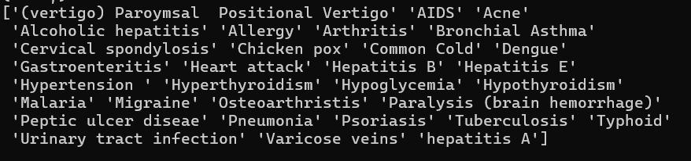

**5.7 MODEL SELECTION**

In selecting the best model for disease classification, four prominent algorithms—Random Forest, K-Nearest Neighbours (KNN), Support Vector Machine (SVM), and Naive Bayes—are compared due to their distinct characteristics and strengths in classification tasks. Random Forest, an ensemble learning method, excels in handling complex datasets with high dimensionality by aggregating the results from multiple decision trees to improve accuracy and robustness. KNN, a simple yet effective algorithm, classifies data based on the similarity to its neighbours, making it well-suited for datasets where similar instances belong to the same class. SVM is powerful for finding the optimal hyperplane that separates different classes, particularly effective in high-dimensional spaces with clear margins of separation. Naive Bayes, grounded in probability theory, leverages Bayes' theorem to classify instances based on the likelihood of feature occurrence, making it efficient and effective for datasets with categorical features. By evaluating these algorithms, the most suitable model for disease classification can be identified based on its performance metrics and suitability for the dataset's characteristics.

**6. SYSTEM DESIGN**

**6.1 ARCHITECTURE DIAGRAM**

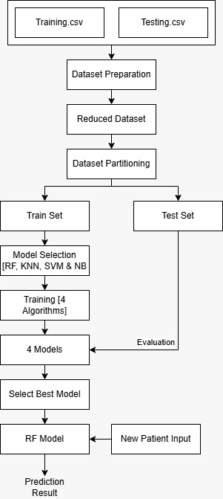

Figure 1 Architecture Diagram

**6.2 ER DIAGRAM**



Figure 2 ER Diagram

**6.3 DATABASE DESIGN**

Database design is the process of converting user-oriented inputs to a computer-based format. The database design phase is used to design the input with in the predefined guidelines. Inaccurate input data are the most common cause of errors in the data processing. Errors entered by data entry operators can be controlled by input design. Input design consists of developing specifications and procedures for data preparation and data validation.

Database system consists of an important part of every project. The management of data involves both definition of structure storage of information and provision of mechanism for manipulation of information. The database designs provide more safety for the information stored, despite system crashes or attempts of unauthorized access to the database. Database files are the key source of information into the system. It is the process of designing database files, which are the key source of information to the system. The files should be properly designed and planned for collection, accumulation, editing and retrieving the required information. The organization of data in database aims to achieve three major objectives:

* Data integration
* Data integrity
* Data independence

The proposed system stores information relevant for processing in the MySQL. This database contains tables, where each table corresponds to one particular type of information. Each piece of information in table is called a field. A table also contains records, which is set of fields. There are primary fields that uniquely identify a record in a table. There are also field that contain primary key from another table called foreign keys.

**6.3.1 Key identification**

Once we have drawn up the list of possible tables and fields, the next step in the logic database is to identify primary key for each table.

* Primary key

A primary key is a special relational database table column designated to uniquely identify all table records. A primary key’s main features are: It must contain a unique value for each row of data. It cannot contain null values.

* Foreign key

A foreign key is in one table that uniquely identifies a row of another table or the same table. In simpler words, the foreign is defined in a second table, but it refers to the primary key in the first table.

**6.4 TABLE DESIGN**

Table 1 : district

|  |  |  |  |  |
| --- | --- | --- | --- | --- |
|  | **Type** | **Null** | **Constraints** | **Description** |
| **Id** | int(11) | No | Primary_Key | Primary key id |
| **Dis** | varchar(100) | No |  | District name |

Table 1 District

Table 2 : location

|  |  |  |  |  |
| --- | --- | --- | --- | --- |
|  | **Type** | **Null** | **Constraints** | **Description** |
| **Id** | int(11) | No | Primary_Key | Primary key id |
| **dis_id** | varchar(100) | No | Foreign_Key | Id of district |
| **Loc** | varchar(100) | No |  | location name |

Table 2 Location

Table 3 : doc_reg

|  |  |  |  |  |
| --- | --- | --- | --- | --- |
|  | **Type** | **Null** | **Constraints** | **Description** |
| **Id** | int(11) | No | Primary Key | Primary key id |
| **Name** | varchar(100) | No |  | Name of doctor |
| **contact** | varchar(100) | No |  | Phone number of doctor |
| **Email** | varchar(100) | No |  | Email of doctor |
| **password** | varchar(100) | No |  | password of doctor |
| **Dob** | varchar(100) | No |  | Date of birth of doctor |
| **gender** | varchar(100) | No |  | Gender of doctor |
| **Photo** | varchar(100) | No |  | Photo of doctor |
| **district** | varchar(100) | No | Foreign Key | Id of district |
| **Loc** | varchar(100) | No | Foreign Key | Id of location |
| **department** | varchar(100) | No |  | Department name |
| **certificate** | varchar(50) | No |  | Certificate of doctor |
| **Apr** | int(11) | No |  | Admin approved or not status |
| **address** | varchar(300) | No |  | Address of doctor |

Table 3 doc_reg

Table 4 : med_reg

|  |  |  |  |  |
| --- | --- | --- | --- | --- |
|  | **Type** | **Null** | **Constraints** | **Description** |
| **Id** | int(11) | No | Primary Key | Primary key id |
| **Name** | varchar(100) | No |  | Name of medical store |
| **contact** | varchar(100) | No |  | Contact of medical store |
| **Email** | varchar(100) | No |  | Email of medical store |
| **password** | varchar(100) | No |  | Password of medical store |
| **Photo** | varchar(100) | No |  | Photo of medical store |
| **district** | varchar(100) | No | Foreign Key | Id of district |
| **Loc** | varchar(100) | No | Foreign Key | Id of location |
| **address** | varchar(500) | No |  | Address of medical store |
| **license** | varchar(50) | No |  | License of medical store |
| **hm_dl** | varchar(10) | No |  | Home delivery available or not |
| **Status** | int(11) | No |  | Medical store closed or open status |
| **Apr** | int(11) | No |  | Admin approved or not |

Table 4 med_reg

Table 5 : reg

|  |  |  |  |  |
| --- | --- | --- | --- | --- |
|  | **Type** | **Null** | **Constraints** | **Description** |
| **id** | int(11) | No | Primary Key | Primary key id |
| **name** | varchar(100) | No |  | name of patient |
| **contact** | varchar(100) | No |  | Contact of patient |
| **email** | varchar(100) | No |  | Email of patient |
| **password** | varchar(100) | No |  | Password of patient |
| **dob** | varchar(100) | No |  | Date d birth of patient |
| **blood** | varchar(100) | No |  | Blood group of patient |
| **gender** | varchar(100) | No |  | Gender of patient |
| **photo** | varchar(100) | No |  | Photo of patient |

Table 5 reg

Table 6 : med_msg

|  |  |  |  |  |
| --- | --- | --- | --- | --- |
|  | **Type** | **Null** | **Constraints** | **description** |
| **id** | int(11) | No | Primary Key | Primary key id |
| **med** | varchar(100) | No | Foreign Key | Id of medical store |
| **msg** | varchar(800) | No |  | Message send by user |
| **uemail** | varchar(100) | No | Foreign Key | User email |
| **date** | varchar(50) | No |  | Message sending date |
| **reply** | varchar(1000) | No |  | Reply send by medical store |

Table 6 med_msg

Table 7 : disease

|  |  |  |  |  |
| --- | --- | --- | --- | --- |
|  | **Type** | **Null** | **Default** | **Description** |
| **id** | int(11) | No | Primary Key | Primary key id |
| **dname** | varchar(100) | No |  | Name of disease |
| **des** | varchar(1000) | No |  | Description about disease |
| **pic** | varchar(100) | No |  | Image of disease |

Table 7 Disease

Table 8 : doc

|  |  |  |  |  |
| --- | --- | --- | --- | --- |
|  | **Type** | **Null** | **Constraints** | **description** |
| **id** | int(11) | No | Primary Key | Primary key id |
| **doc_id** | int(11) | No | Foreign Key | Id of doctor |
| **des_id** | int(11) | No | Foreign Key | Id of disease |

Table 8 doc

Table 9 : log

|  |  |  |  |  |
| --- | --- | --- | --- | --- |
|  | **Type** | **Null** | **Constraints** | **Description** |
| **id** | int(11) | No | Primary Key | Primary key id |
| **email** | varchar(100) | No | Foreign Key | Login email for user |
| **password** | varchar(100) | No |  | Login password for user |
| **utype** | varchar(100) | No |  | Type of user |
| **ustatus** | int(11) | No |  | User status |

Table 9 log

Table 10 : mng_time

|  |  |  |  |  |
| --- | --- | --- | --- | --- |
|  | **Type** | **Null** | **Constraints** | **Description** |
| **id** | int(11) | No | Primary Key | Primary key id |
| **email** | varchar(100) | No | Foreign Key | Email of doctor |
| **day** | varchar(100) | No |  | Consulting day |
| **start** | varchar(100) | No |  | Start time |
| **end** | varchar(100) | No |  | End time |
| **pat_no** | int(11) | No |  | No of patients handled |

Table 10 mng_time

Table 11 : appointments

|  |  |  |  |  |
| --- | --- | --- | --- | --- |
|  | **Type** | **Null** | **Constraints** | **Description** |
| **id** | int(11) | No | Primary Key | Primary key id |
| **uname** | varchar(100) | No | Foreign Key | Email of patient |
| **doc** | varchar(100) | No |  | Email of doctor |
| **date** | varchar(100) | No |  | Date of booking appointment |
| **name** | varchar(100) | No |  | Name of patient |
| **slot_id** | varchar(100) | No | Foreign Key | Unique id for mng_time |

Table 11 appointments

**6.5 DATAFLOW DIAGRAM**

A DFD is a network that describes the flow of data throughout a system, data stores, and the process that change or transform data flows. Data Flow Diagrams are also known as Data Flow Graphs. DFDs are commonly used during the problem analysis stage. They are useful in understanding a system and can be effectively used for partitioning during analysis.

The basic elements of DFD are:

|  |  |
| --- | --- |
|  | **Oval**  Process: A process in the data flow diagram used to represent some amount of work being performed on data. The oval or bubble shape is used to represent the processes in a data flow diagram. |
|  | **Rectangle**  External Entity: This represents any outside agency, which interact with the system. It represents the source and destination of the data for the system under consideration. The rectangle shape is used to represent the external entity in the data flow diagram. |
|  | **Arrowhead on the data flow line**  Data Flow Direction: In a data flow diagram (DFD), data flow is represented by an arrow symbol that indicates the direction of flow. The flow of data into or out of a process is represented by curved or straight lines with arrows. |
|  | **parallel horizontal lines**  Data Store: A data store or data repository is used in a data-flow diagram to represent a situation when the system must retain data because one or more processes need to use the stored data in a later time. |
|  | **small circle**  Data Flow Splitting/Merging: A split/merge allows you to split a flow into several flows to send data to different destinations, or merge flows from different sources into one flow. Split/merges are based on synchronizations (see Synchronizations (BPM)) with a Split/Merge stereotype. |

Context Diagram

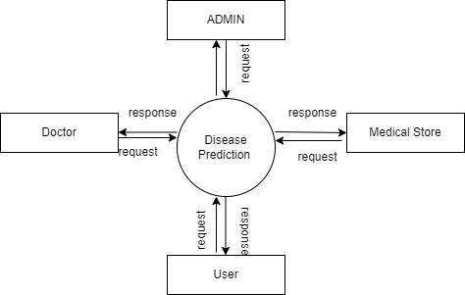

Figure 3 Context Diagram

Level 1 admin

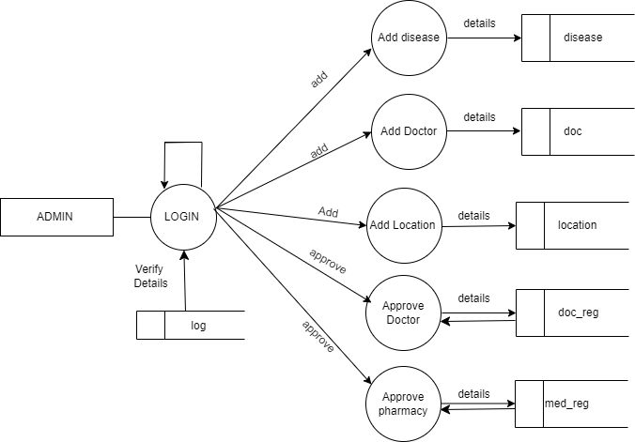

Figure 4 Level 1 Admin

Level 1 USER



Figure 5 Level 1 User

Level 1 doctor

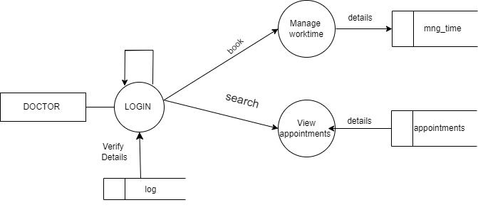

Figure 6 Level 1 Doctor

Level 1 Medical Store

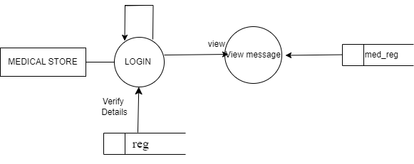

Figure 7 Level 1 Medical Store

**6.6 USECASE DIAGRAM**

A Use Case Diagram displays the relationship among actors and Use Cases. Use Case Diagrams are drawn to capture the functional requirements of a system. Use case diagrams are used to gather the requirements of a system including internal and external influences. These requirements are mostly design requirements.

* To identify functions and how roles interact with them.
* For a high-level view of the system.
* To identify internal and external actors
* The two main components of Use Case Diagrams are actor and cases.
* Actor

Actor in a Use Case Diagrams is any entity that performs a role in one given system. This could be a person, organization or an external system and usually drawn like skeleton shown below:

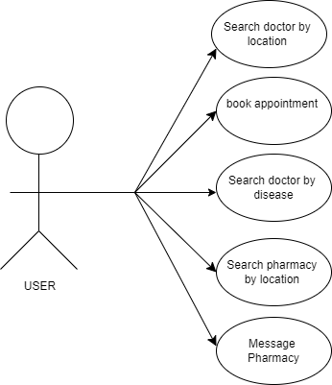

Figure 8 Use Case Diagram User

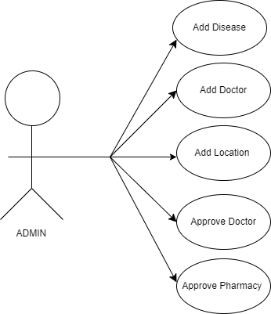

Figure 9 Use Case Diagram Admin

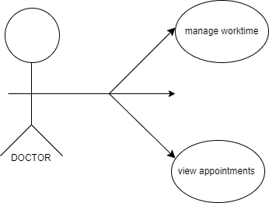

Figure 10 Use Case Diagram Doctor

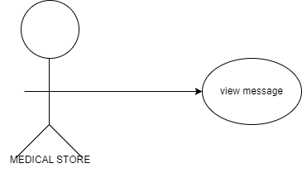

Figure 11 Use Case Diagram Medical Store

**6.7 STRUCTURAL CHART**

A structure chart is a visual representation of a system's components, including modules, procedures, and functions, that shows the hierarchical relationships between them. Structure charts are often used in structured programming and top-down modular design. They are made up of boxes that represent the main logical actions, also called modules. The tree structure visualizes the relationships between modules.

Structure Chart partitions the system into black boxes (functionality of the system is known to the users, but inner details are unknown).

1. Inputs are given to the black boxes and appropriate outputs are generated.
2. Modules at the top level are called modules at low level.
3. Components are read from top to bottom and left to right.
4. When a module calls another, it views the called module as a black box, passing the required parameters and receiving results.

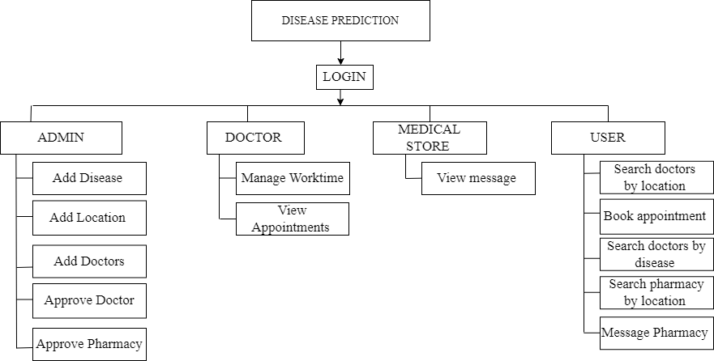

Figure 12 Structure Chart

**6.8 FLOWCHART**

Admin

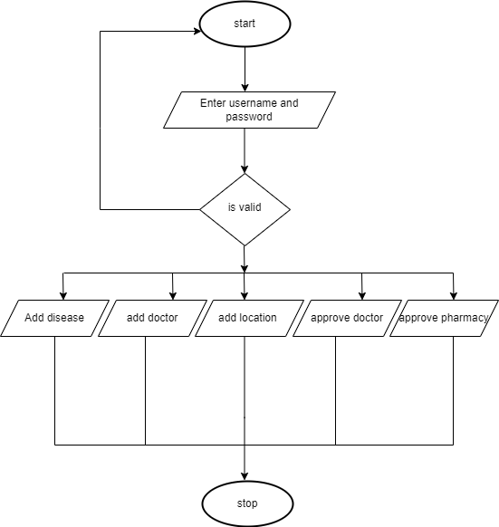

Figure 13 Flow Chart Admin

User

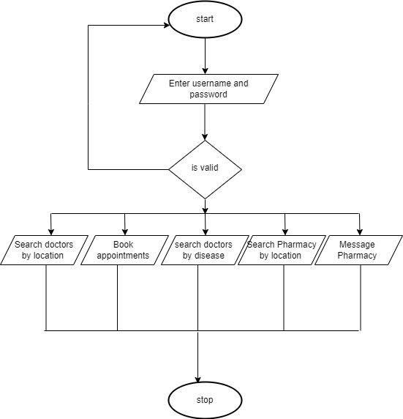

Figure 14 User Flowchart

Doctor

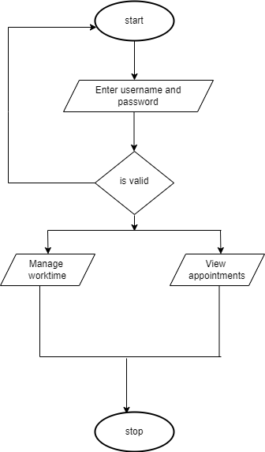

Figure 15 Doctor Flowchart

Medical Store

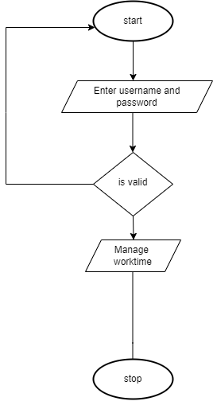

Figure 16 Medical Store Flowchart

**7. MODULE DESCRIPTION**

**7.1 ADMIN MODULE**

* The Admin module manages disease data by allowing input of name, description, and symptoms, with validation to ensure unique disease names and correct formatting.
* Doctors can be added by entering their name, specialization, contact details, and location, with validation to prevent duplicate entries, especially for email addresses.
* Locations can be added with details such as name, address, and services, ensuring address accuracy and uniqueness of location names.
* The system ensures all data entries are accurate, validated, and properly maintained to prevent duplication and errors.

**7.2 USER MODULE**

* Users can search for doctors by location and receive a list of doctors with their specializations and contact information.
* Appointment booking is available by providing doctor’s ID, user contact details, and preferred date/time, with doctor availability checked before confirmation.
* Users can search for doctors by disease to find specialists for specific health concerns, with relevant contact information included.
* Pharmacies can be searched by location, and users can directly message pharmacies for inquiries or requests.

**7.3 DOCTOR MODULE**

* Doctors can manage their schedules by setting availability, specifying workdays and appointment time slots.
* The module allows doctors to update their schedules to ensure alignment with existing appointments.
* Doctors can view a list of upcoming appointments, including patient details, appointment dates, times, and related notes.
* This functionality helps doctors prepare for patient interactions and manage their daily workflow effectively.

**7.4 MEDICAL STORE MODULE**

* Pharmacy staff can view user messages, including details, content, and timestamps.
* Messages may include product inquiries, availability requests, or other communications.
* Staff can respond promptly to ensure timely information for users.
* This feature supports strong customer relations and efficient communication.

**7.5 USER INTERFACE MODULE**

In the user interface, provide intuitive forms for users to input symptoms, medical history, and preferences, ensuring a seamless experience. It should display predicted diseases, suggested medical departments, and relevant recommendations clearly. Use dropdown menus, checkboxes, and radio buttons for easy data entry, and incorporate visual aids like icons or color coding to indicate the severity or likelihood of conditions. Ensure the interface is accessible, mobile-friendly, and includes user feedback options to enhance usability and satisfaction. This design will make it easier for users to navigate and interpret the results, improving the overall user experience.

**7.6 DISEASE DETECTION MODULE**

In the disease detection module, predict diseases based on user input using trained machine learning models. Map predicted diseases to relevant medical departments for user guidance, ensuring users receive appropriate recommendations and next steps.

**8. SYSTEM IMPLEMENTATION**

**8.1 TRAINING CODE**

# Load your data

df = pd.read_csv('df_filtered.csv')

# Separate features and target variable

X = df.drop(columns=['prognosis'])

y = df['prognosis']

print(X.shape)

print(y.shape)

with open('label_encoder.pkl', 'rb') as f:

label_encoder = pickle.load(f)

X_train, X_test, y_train, y_test = train_test_split(X, y, test_size=0.3, stratify=y, random_state=2)

unique_labels = np.unique(label_encoder.inverse_transform(y_test))

print("Unique Labels:",unique_labels)

results = {}

algorithms = [('RF',RandomForestClassifier(n_estimators=100, random_state=1)),

('KNN', KNeighborsClassifier(n_neighbors=5)),

('SVM', SVC(probability=True)),

('Naive Bayes', GaussianNB())]

best_model = None

best_accuracy = 0

for name, classifier in algorithms:

classifier.fit(X_train, y_train)

**8.2 PREDICTION CODE**

import joblib

import pickle

classifier= joblib.load('RandomForestClassifier_model.joblib')

with open('label_encoder.pkl', 'rb') as f:

label_encoder = pickle.load(f)

input=[0,0,1,0,0,0,0,0,0,0,0,0,0,0,0,0,0,0,0,0,0,0,0,0,0,0,0,0,0,0,0,0,0,0,0,0,0,0,0,0,0,1,1,1,0]

y_pred=classifier.predict([input])

print(y_pred)

y_pred=label_encoder.inverse_transform(y_pred)

print(y_pred)

**9. RESULT AND DISCUSSION**

**9.1 CONFUSION MATRIX**

**9.1.1 Random Forest**

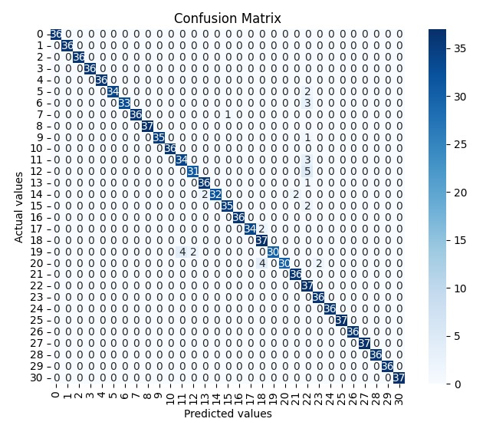

Figure 17 Random Forest

The confusion matrix for the Random Forest model shows strong performance in disease detection, with most of the predicted values aligning closely with the actual values, indicating high accuracy. The diagonal dominance in the matrix suggests that the model is effectively classifying the diseases, as the majority of the actual and predicted classes match. Misclassifications, as indicated by the off-diagonal elements, are minimal and sparse, implying that the model maintains precision across different disease categories. This overall pattern highlights the Random Forest's robustness in handling complex, multi-class classification tasks in the context of disease detection.

**9.1.2 K-Nearest Neighbors (KNN)**

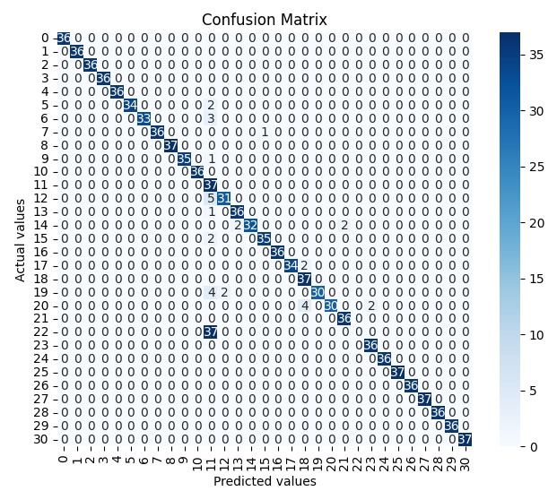

Figure 18 K-Nearest Neighbors

The confusion matrix for the K-Nearest Neighbors (KNN) model reveals a strong performance in disease detection, with the majority of predictions accurately corresponding to the actual disease classes, as seen by the dominance of values along the diagonal. This indicates that KNN is effectively identifying and classifying the various diseases in the dataset. However, there are a few off-diagonal elements, representing minor misclassifications. These errors are minimal, suggesting that KNN performs well in distinguishing between the 31 distinct diseases but might occasionally struggle with closely related classes. Overall, the KNN model demonstrates reliable accuracy in this multi-class classification task, making it a valuable component of the disease detection system.

**9.1.3 Support Vector Machines (SVM)**

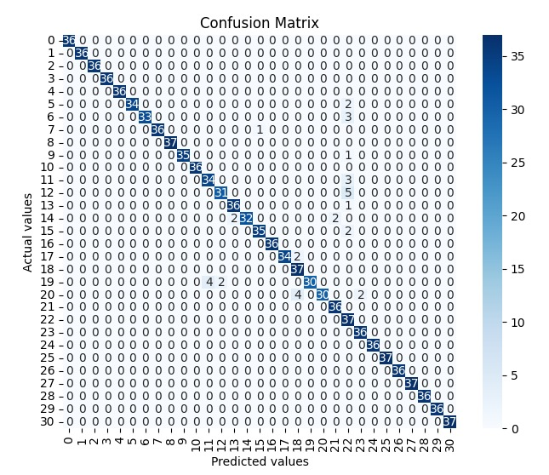

Figure 19 Support Vector Machine

The confusion matrix for the Support Vector Machine (SVM) model shows a highly accurate performance in disease detection. The matrix is strongly diagonal, indicating that the majority of actual disease classes are correctly predicted by the SVM model. The high concentration of values along the diagonal with very few off-diagonal misclassifications demonstrates that SVM effectively distinguishes between the 31 different diseases. The few misclassifications present are sparse, suggesting that while SVM might occasionally confuse similar disease classes, it generally provides precise and reliable predictions. This strong performance highlights the SVM model's capability in handling complex multi-class classification tasks in the context of disease detection.

**9.1.4 Naïve Bayes**

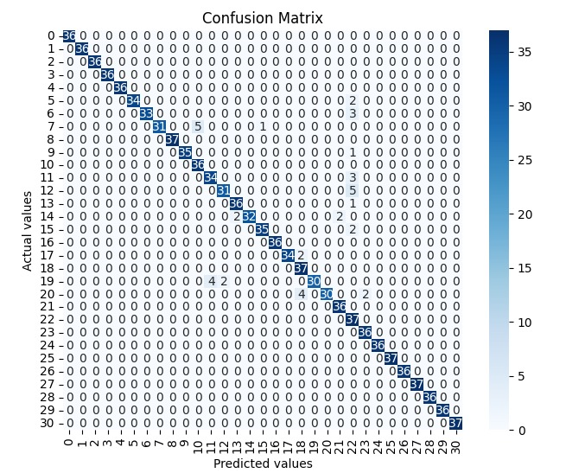

Figure 20 Naïve Bayes

Based on the provided confusion matrix, the Naive Bayes classifier exhibits strong performance, particularly in correctly predicting the most frequent classes (represented by the darker squares along the diagonal). This indicates high accuracy for these common categories. However, there's potential for improvement in distinguishing between less frequent classes, as evidenced by the lighter squares off the diagonal. This suggests that the model might benefit from additional training data or feature engineering to better handle these underrepresented categories.

**9.2 COMPARISON OF EVALUATION RESULTS**

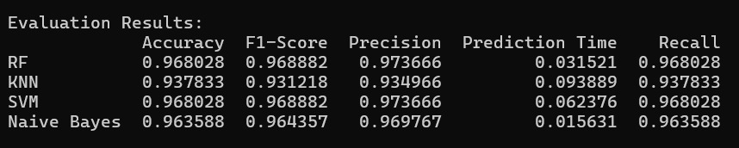

The Random Forest and SVM models show the highest accuracy (0.968028), F1-Score (0.968882), precision (0.973666), and recall (0.968028), indicating strong and consistent performance across all evaluation metrics. Both models also exhibit relatively low prediction times, with RF being faster (0.031521 seconds) compared to SVM (0.062376 seconds). KNN has a lower accuracy (0.937833) and F1-Score (0.931218), as well as the longest prediction time (0.093889 seconds), making it less efficient and effective compared to RF and SVM. Naive Bayes, while slightly lower in accuracy (0.963588) and recall (0.963588), still performs well with high precision (0.969767) and the shortest prediction time (0.015631 seconds), indicating that it is a fast and reasonably accurate model. Overall, RF and SVM are the top performers in terms of accuracy and F1-Score, but Naive Bayes offers a good balance of speed and performance.

# 10. SYSTEM TESTING

Software testing is a critical element of software quality assurance and represents the ultimate review of specification, design and coding. System testing is actually a series of different test whose purpose is to fully exercise the computer-based system. Although each has a different purpose, all of them work to verify that all system elements have been properly integrated and all of them perform allocated functions. If the test is conducted successfully, it will uncover errors in the software. A second benefit is that the software is appearing to be working according to specification and that performance requirements appear to have been met. System testing is an inexpensive but critical process that can take as much as 50|% of budget for development, the view of testing holds by users that is performed to prove that there is no error in the program. However, this is virtually impossible since analysis cannot prove that software is free and clear to errors. Testing is the process of executing a program with explicit intensions of finding errors.

## 10.1 LEVELS OF TESTING

### 10.1.1 Unit Testing

Unit testing comprises of a set of tests performed by an individual programmer prior to the integration of unit into large system. A large program unit is usually small enough that the programmer who developed and that can be in great detail and certainly in greater detail than possible when the unit is integrated into an evolving software project. Module unit testing should be as exhaustive as possible to ensure that each representation is handled by each module that has been tested. All the units that make up the system were tested independently to ensure that they work as required. These types of test are usually written by developers as they work on code (white-box style), to ensure that the specific function might have multiple tests, to catch corner cases or other branches I the code. Unit testing alone cannot verify the functionality of a piece of software, but rather is used to assure that the building blocks the software uses work independently of each other.

### 10.1.2 Integration testing

Integration testing is a system technique for constructing program structure while at the same time conducting tests to uncover errors associated with interfacing. The objective is to take the unit tested modules and build a program structure that has been dictated by design.

Integration testing is any type of software testing that seeks to verify the interfaces between components against a software design. Software components may be integrated in an iterative way or all together (“big bang”). Normally, the former is considered as a better practice since it allows interface issues to be located more quickly and fixed.

Integration testing works to defects in the interfaces and interaction between integrated components (modules). Progressively larger groups of tested software components corresponding to elements of the architectural design are integrated and tested until the software works as system.

### 10.1.3 System testing

System testing is actually a series of different tests, whose purpose is to test the completed system in it’s entirely as a whole exercise. System testing involves security testing, performance testing and recovery testing. After output testing the whole system is tested in different platforms and browsers for testing the overall functionality and user interface of the system in various environment. This testing is done after completing all the testing, ie system testing is the final phase of the testing process.

### 10.1.4 Validation testing

At the culmination of integration testing, the software was completely assembled as a package, interfacing errors have been uncovered and corrected and a final series of software validation testing began. In validation testing the entered data validated for correct format, and correct order.

### 10.1.5 Output testing

After performing validation test, the next phase is output test of the system, since no system could be useful if it does not produce desired output in the desired format. The output format was considered in two ways: one is on the screen and the other as a printed form.

### 10.1.6 User acceptance testing

**User Acceptance Testing** (**UAT**) is a type of **testing** performed by the end **user** or the client to verify/accept the **software** system before moving the **software** application to the production environment. **UAT** is done in the final phase of **testing** after functional, integration and system **testing** is done.

**10.2 TEST CASE**

|  |  |  |  |  |  |
| --- | --- | --- | --- | --- | --- |
| **Test ID** | **Test Steps** | **Test Data** | **Expected Results** | **Actual Result** | **Status** |
| 1 | Search for a doctor by location | District: “Trivandrum”,location: “Pattom” | List of doctors in Pattom displayed (if available) | List of doctors in Pattom displayed(if available) | Pass |
| 2 | Search for a doctor by disease | Disease: "Diabetes" | List of doctors specializing in diabetes displayed(if added) | List of doctors specializing in diabetes displayed(if added) | Pass |
| 3 | Book an appointment with a doctor | Select doctor, choose time slot | Appointment confirmation received | Appointment confirmation received | Pass |
| 4 | Search for nearby pharmacies | District: “Trivandrum”,location: “Pattom” | List of pharmacies in Pattom | List of pharmacies in Pattom | Pass |
| 5 | Send a message to a pharmacy | Inquiry: "Is Paracetamol available?" | Display inquiry message and reply(if pharmacy sent reply) | Display inquiry message and reply(if pharmacy sent reply) | Pass |
| 6 | Doctor updates availability | Set availability of day and time | Availability updated | Availability updated | Pass |
| 7 | Admin adds a new disease category | New disease details | Display added disease details | Display added disease details | Pass |
| 8 | Admin approves a new doctor | Doctor: "Dr. Smith" | Doctor successfully approved | Doctor successfully approved | Pass |
| 9 | System predicts disease based on symptoms | Symptoms: "Fever, cough" | Possible disease predictions displayed | Possible disease predictions displayed | Pass |

Table 12 test case

**11. CONCLUSION**

The proposed method for disease classification demonstrates its effectiveness through the evaluation and comparison of four machine learning algorithms: Random Forest, Naive Bayes, K-Nearest Neighbours (KNN), and Support Vector Machine (SVM). Among these, Random Forest and SVM both achieved an impressive accuracy of 97%, indicating their strong performance in accurately classifying diseases based on the selected features. Naive Bayes followed closely with an accuracy of 96%, while KNN achieved a respectable 94%. These results highlight the robustness of the algorithms, particularly Random Forest and SVM, in handling the complexity of the dataset and delivering high predictive accuracy.

Given the comparable accuracy of Random Forest and SVM, the final decision to deploy the model was influenced by the speed of prediction. Random Forest, with its ensemble learning approach, not only provided high accuracy but also delivered faster predictions compared to SVM. This makes it the preferred choice for deployment in real-world applications where both accuracy and efficiency are critical. The combination of high accuracy and rapid prediction speed ensures that the proposed method offers a reliable and practical solution for disease classification, making it superior to the other evaluated models.

Furthermore, the integration of this machine learning model with a user-friendly web interface significantly improves the accessibility and convenience of healthcare services. Users benefit from immediate and accurate disease detection, along with the ability to find and book appointments with relevant specialists or consult nearby medical stores in real-time. This seamless combination of technology and healthcare not only streamlines the process for users but also optimizes healthcare delivery, ensuring that individuals receive timely and appropriate medical attention. The proposed method, by merging high-accuracy machine learning with practical, real-world applications, represents a superior approach to healthcare management, offering a holistic solution that addresses both diagnostic and logistical needs effectively

**12. FUTURE ENHANCEMENTS**

One potential enhancement is incorporating a broader range of diseases and symptoms into the dataset, allowing the model to detect and classify a more extensive variety of health conditions. This could be achieved by continuously updating the dataset with new medical research and data from various healthcare sources. Additionally, integrating advanced machine learning techniques such as deep learning or ensemble methods could further improve the accuracy and robustness of the model, enabling it to handle more complex diagnostic scenarios and rare diseases. These improvements would make the system even more comprehensive and reliable, offering users a more extensive diagnostic tool.

Another avenue for enhancement lies in enriching the web-based search facility with additional features and services. For example, incorporating telemedicine capabilities would allow users to consult with healthcare providers directly through the platform, offering virtual consultations and remote monitoring.

.

**13. REFERENCE**

1. Latha, C. B. C., & Jeeva, S. C. (2019). Improving the accuracy of prediction of heart disease risk based on ensemble classification techniques. International Journal of Engineering and Advanced Technology (IJEAT), 8(3), 1010-1017.
2. Alim, M. A., & Habib, S. (2020). Robust heart disease prediction: A novel approach based on significant feature and ensemble learning model. Journal of King Saud University - Computer and Information Sciences.
3. Alalawi, H. H., & Alsuwat, M. S. (2021). Detection of cardiovascular disease using machine learning classification models. Journal of Computer Science, 17(4), 451-459.
4. Hassan, M. M., & Amiri, N. (2019). Classification of imbalanced data of diabetes disease using machine learning algorithms. Journal of King Saud University - Computer and Information Sciences.
5. Rohini, M., & Surendran, D. (2019). Classification of neurodegenerative disease stages using ensemble machine learning classifiers. International Journal of Recent Technology and Engineering (IJRTE), 8(1), 200-207.
6. Mohan, S., Thirumalai, C., & Srivastava, G. (2019). Effective heart disease prediction using hybrid machine learning techniques. IEEE Access, 7, 81542-81554.
7. Tiwari, P., & Singh, V. (2021). Diabetes disease prediction using significant attribute selection and classification approach. International Journal of Information Technology, 13(1), 95-102.
8. Jabbar, M. A. (n.d.). Breast cancer data classification using ensemble machine learning. Journal of Biomedical Informatics.
9. Hussain, A., Malik, H., & Chaudhry, M. U. (2022). Supervised learning based classification of cardiovascular diseases. IEEE Access, 10, 123456-123465.
10. Stella, A., & Kumari, P. V. (2021, October). Forecasting of chronic kidney disease and analysis of the classifiers using ML based classification approaches. In 2021 International Conference on Advancements in Electrical, Electronics, Communication, Computing and Automation (ICAECA) (pp. 1-5). IEEE.

**14. APPENDIX**

**14.1 UI SCREENSHOTS**

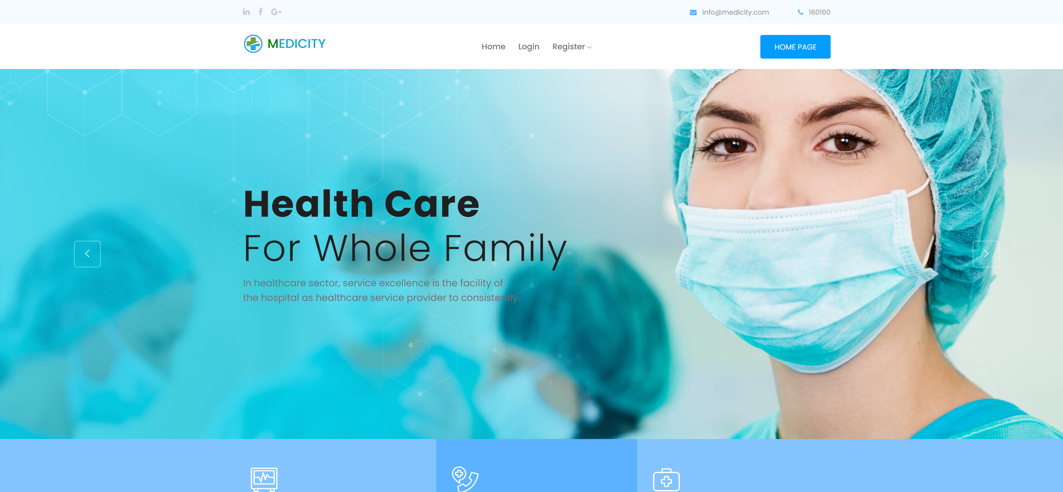

Figure 21 Home Page

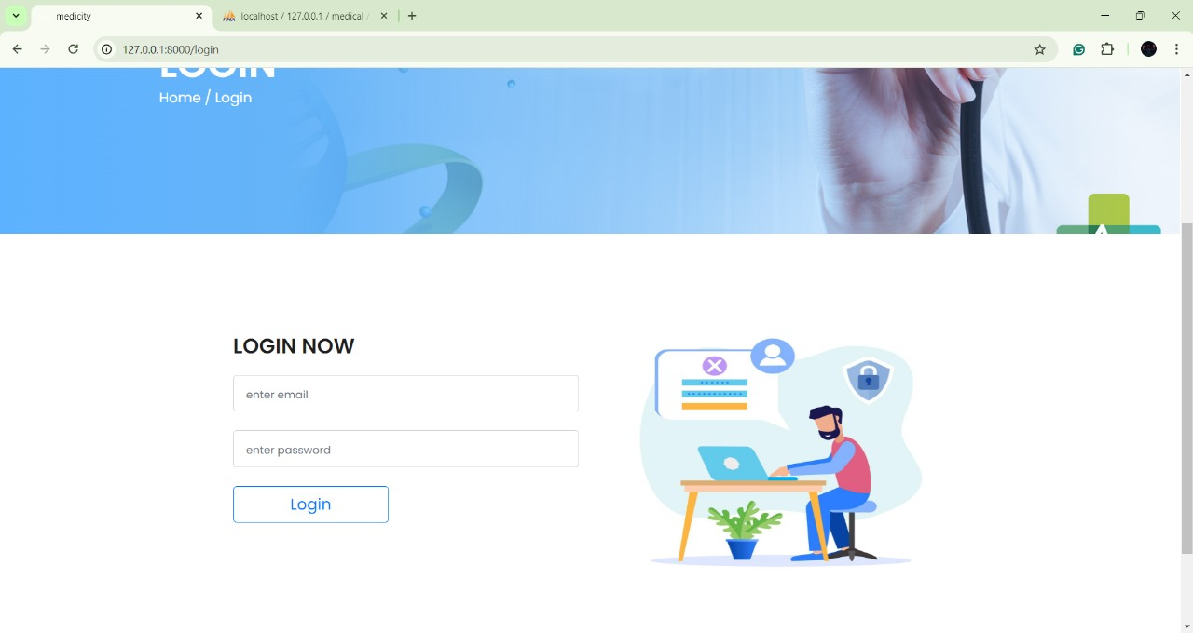

Figure 22 Login Page

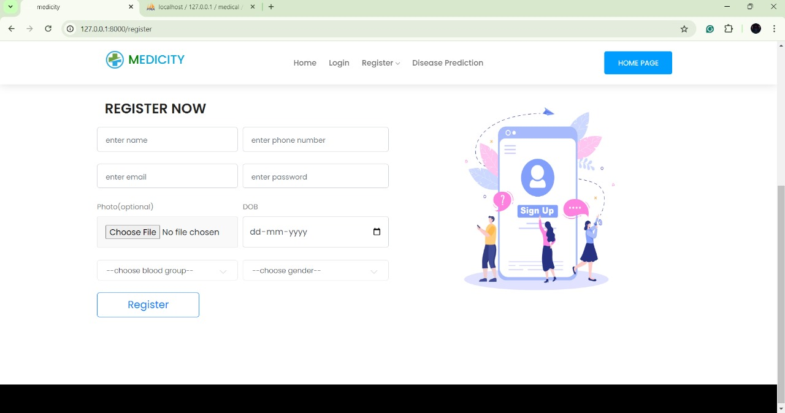

Figure 23 User Registration Page

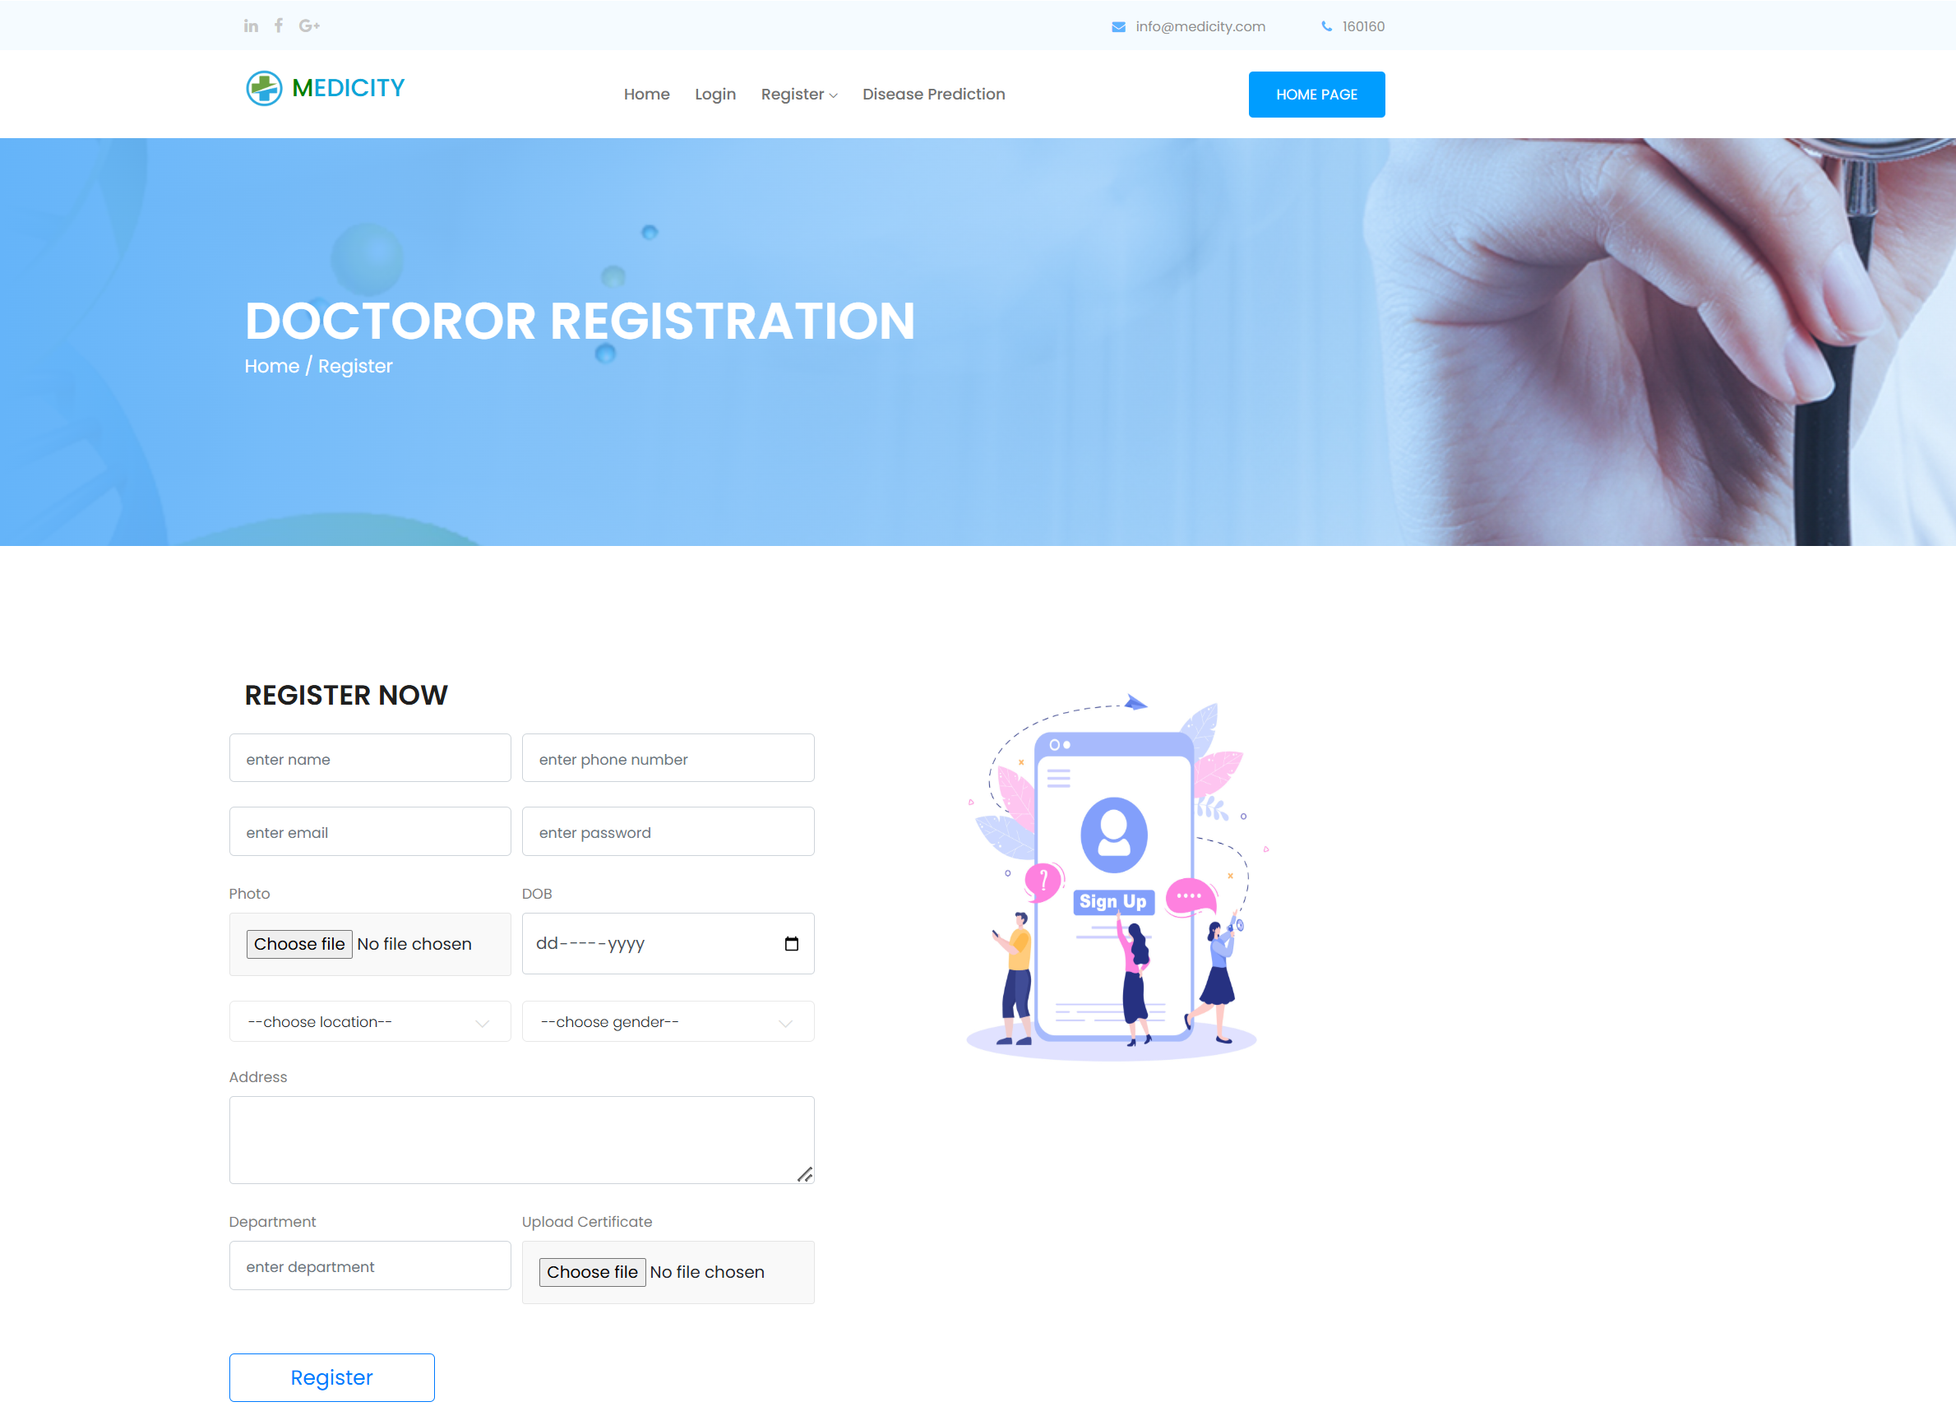

Figure 24 Doctor Registration Page

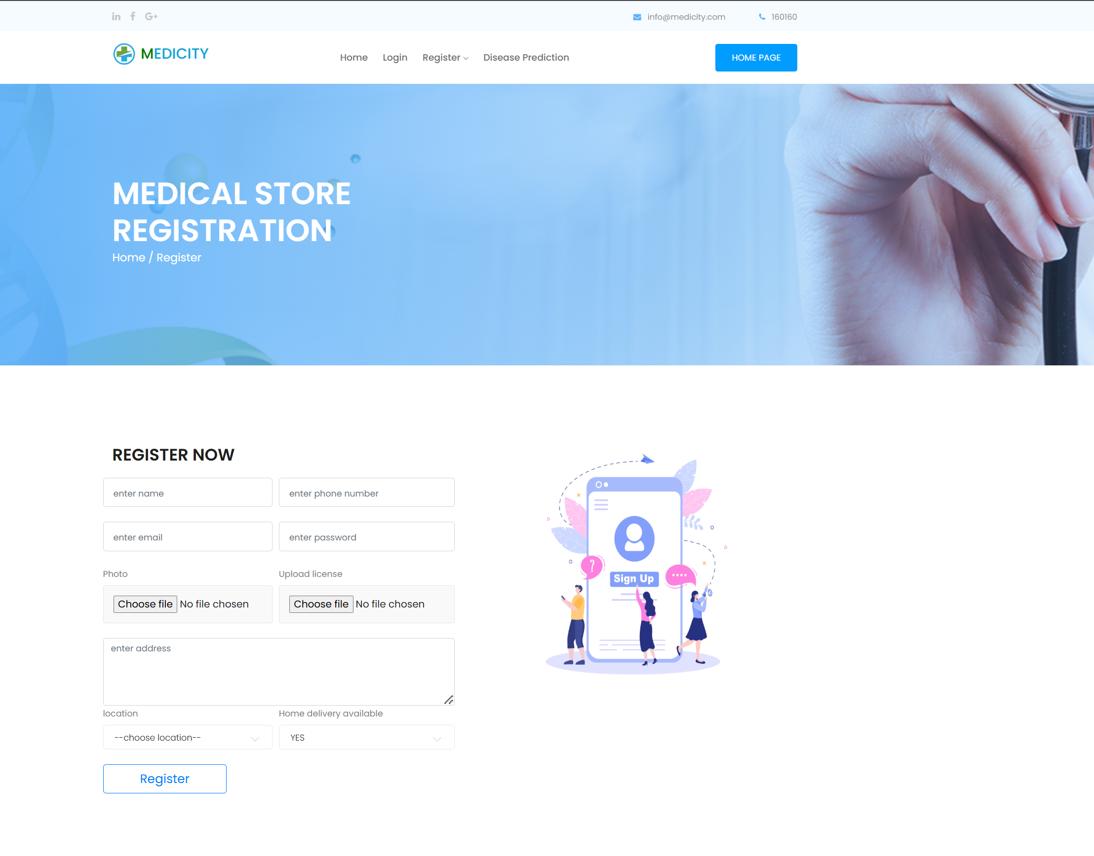

Figure 25 Medical Store Registration Page

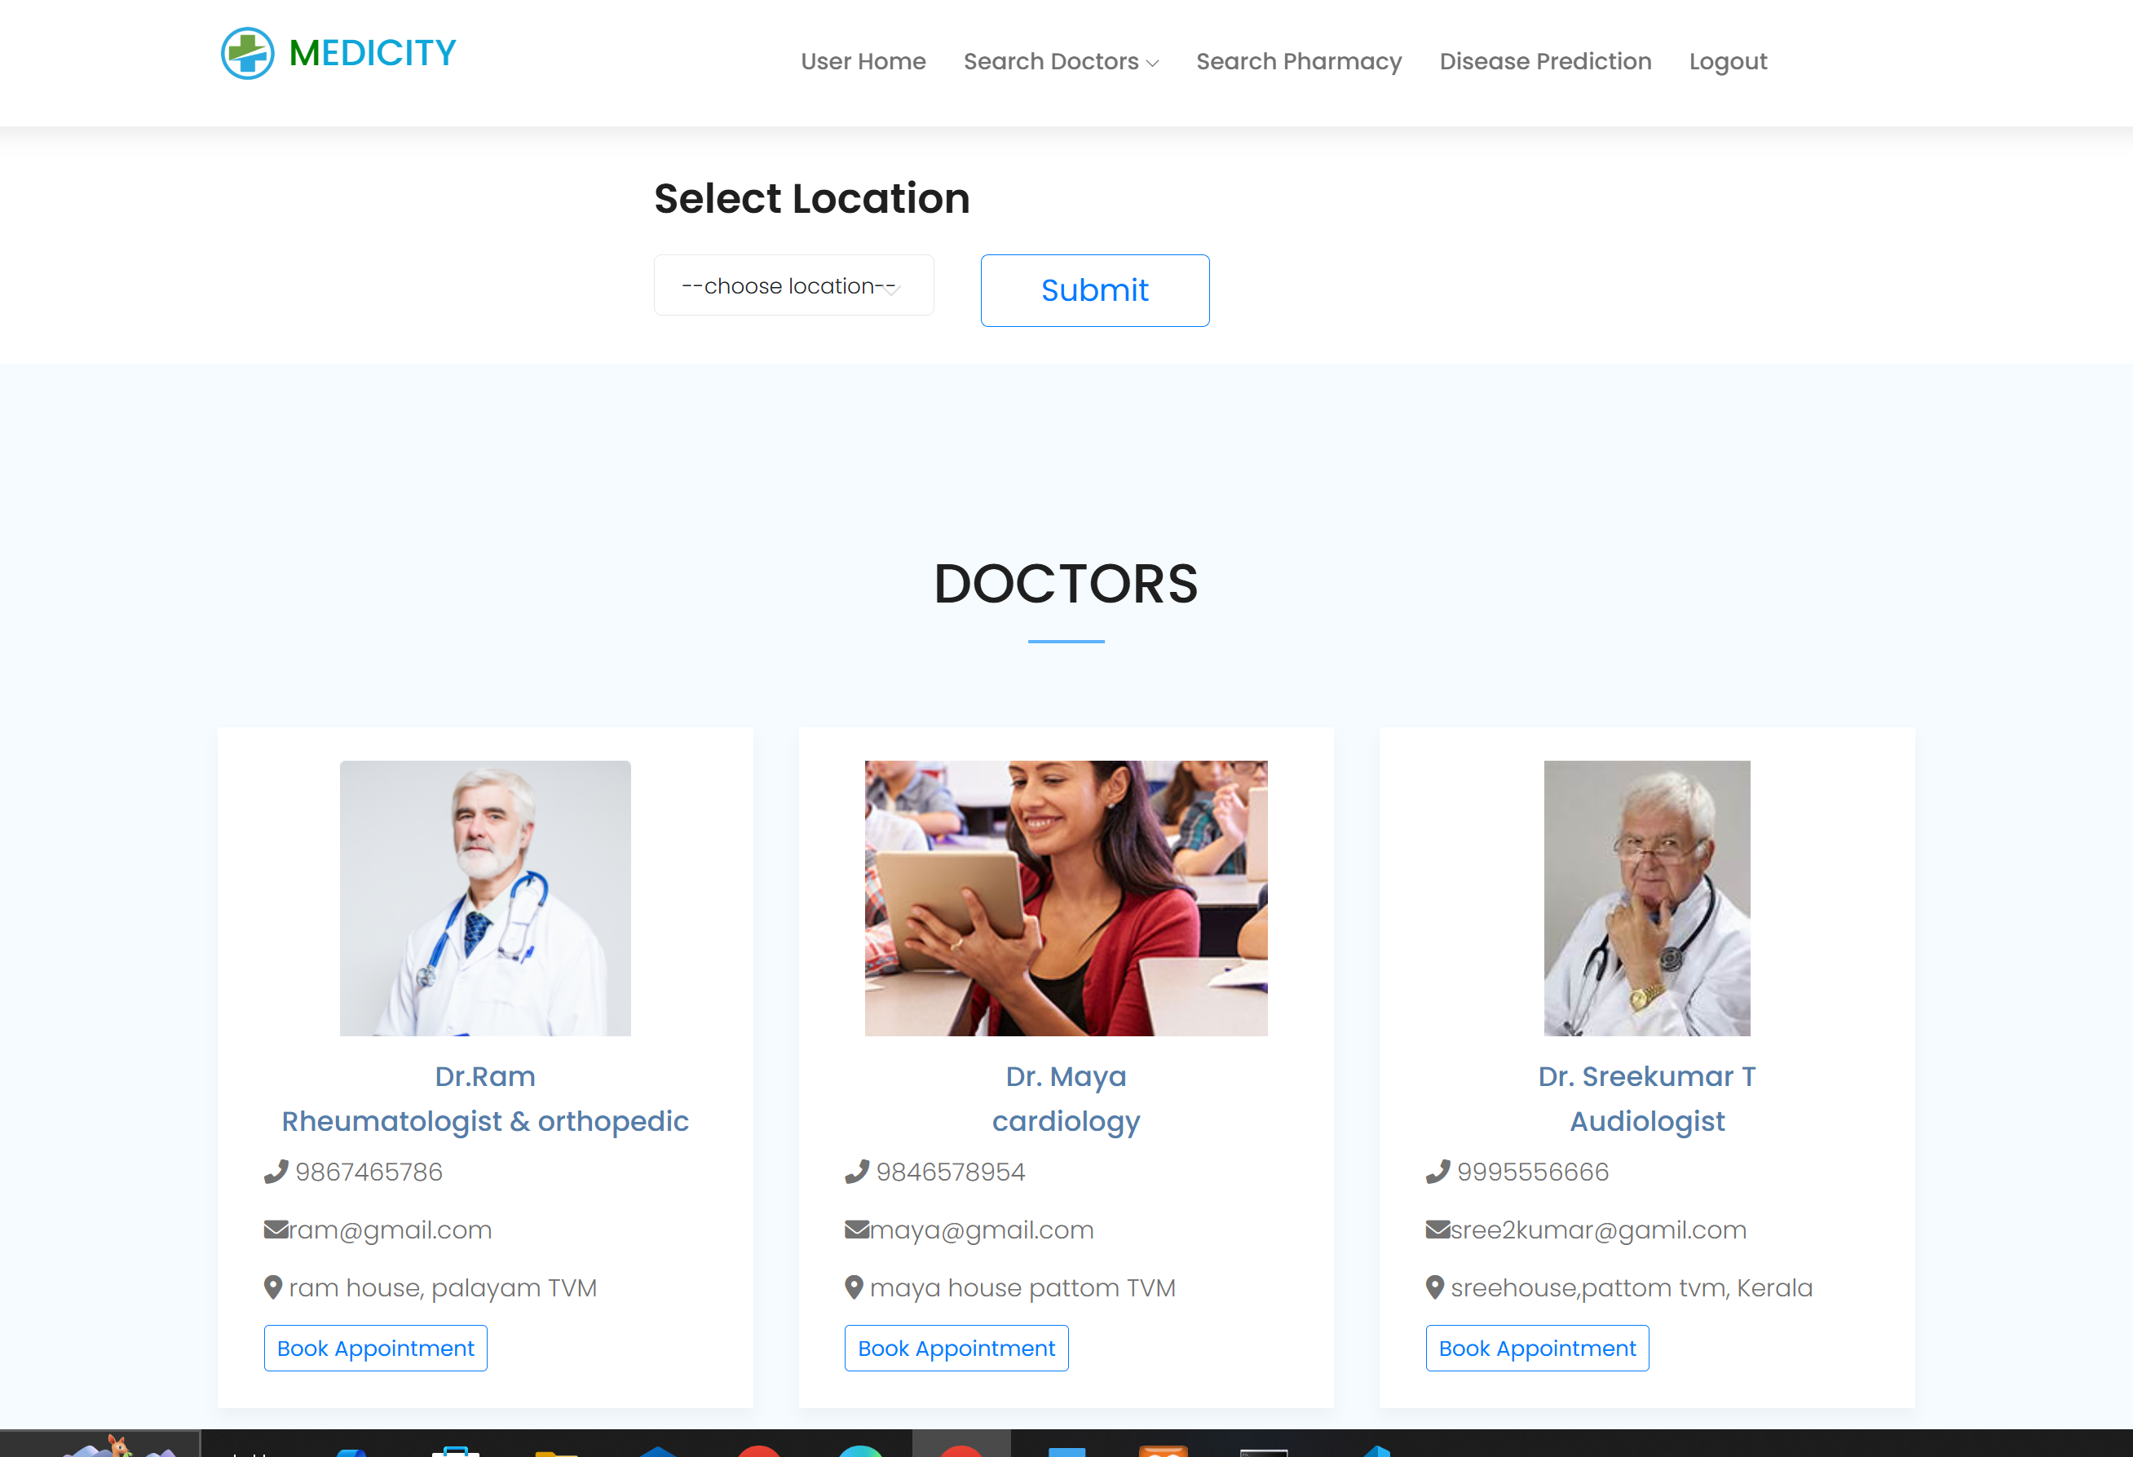

Figure 26 Search Doctor by Location Page

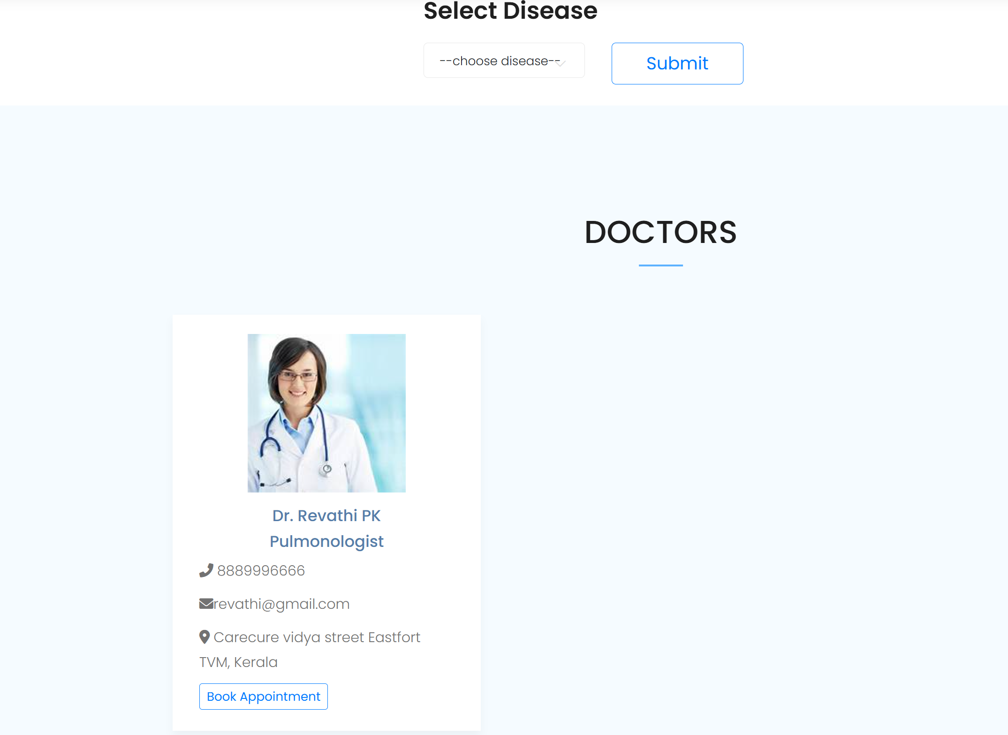

Figure 27 Search Doctor by Disease Page

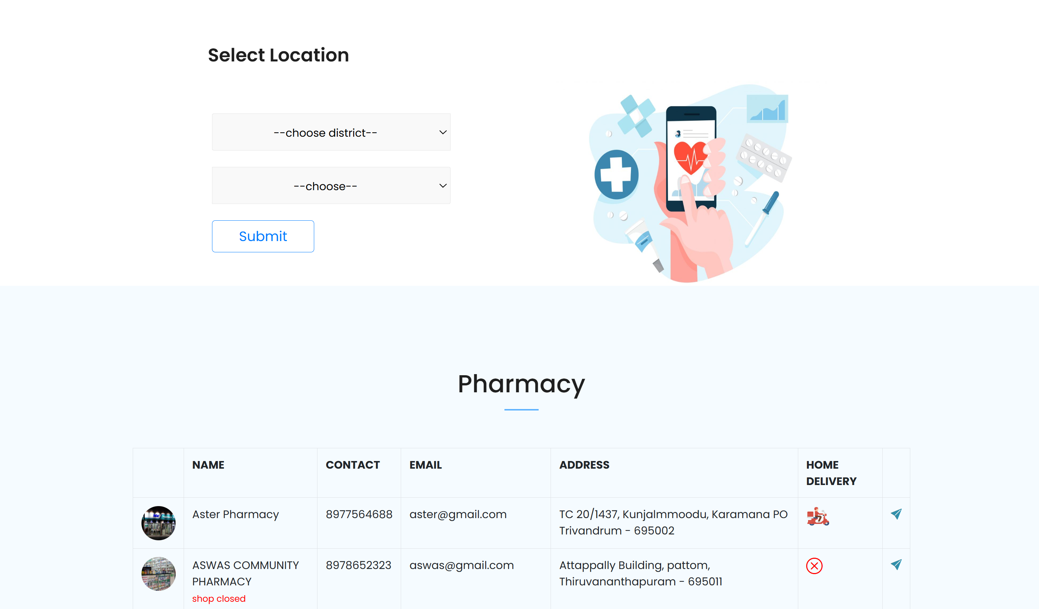

Figure 28 Search Pharmacy Page

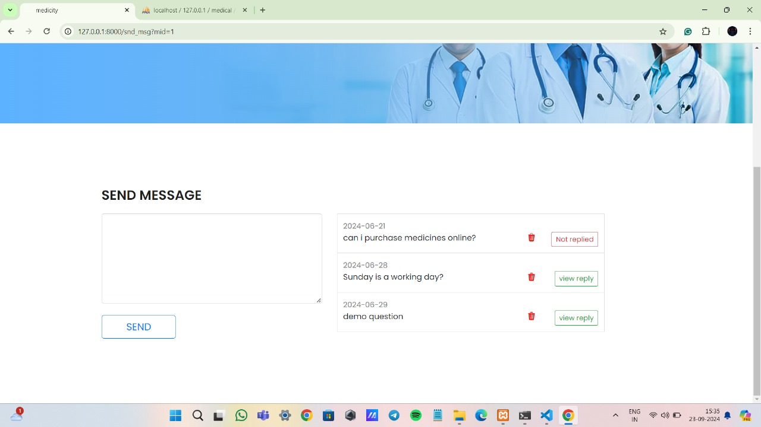

Figure 29 Pharmacy Message Page

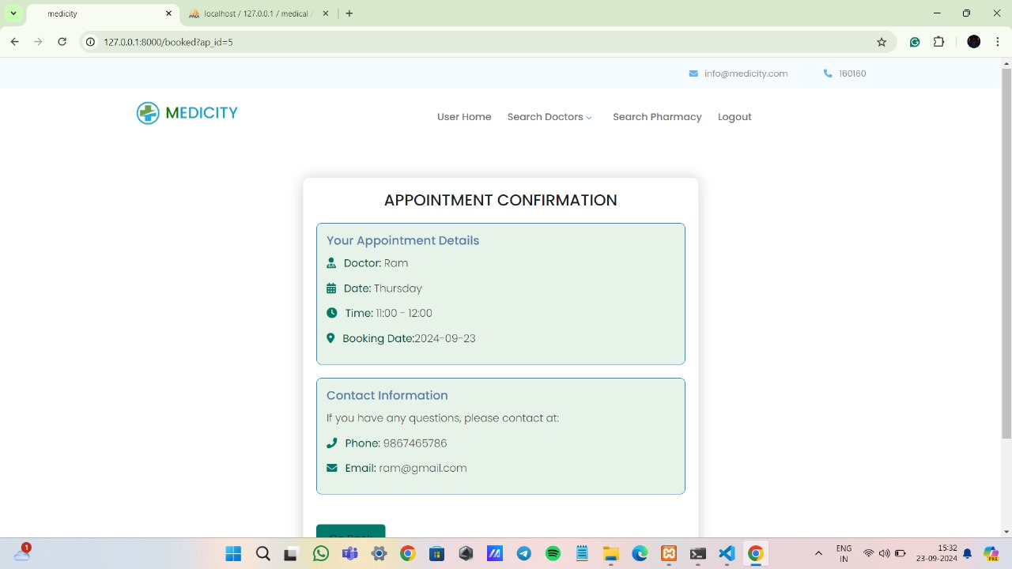

Figure 30 Appointment Confirmation Page

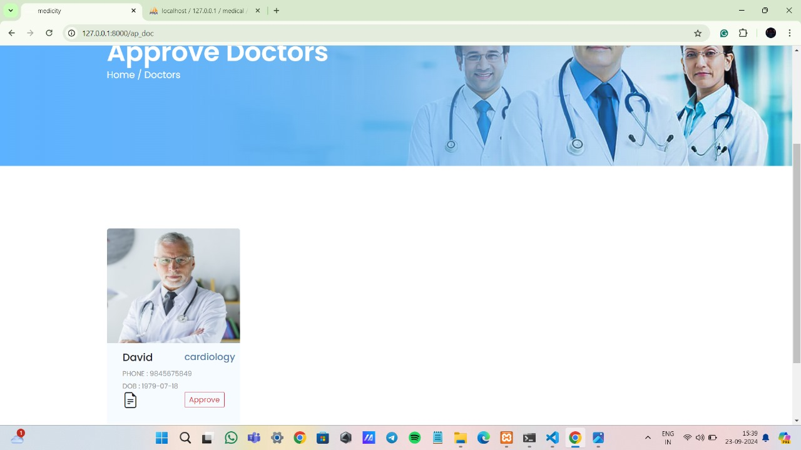

Figure 31 Doctor Approval Page

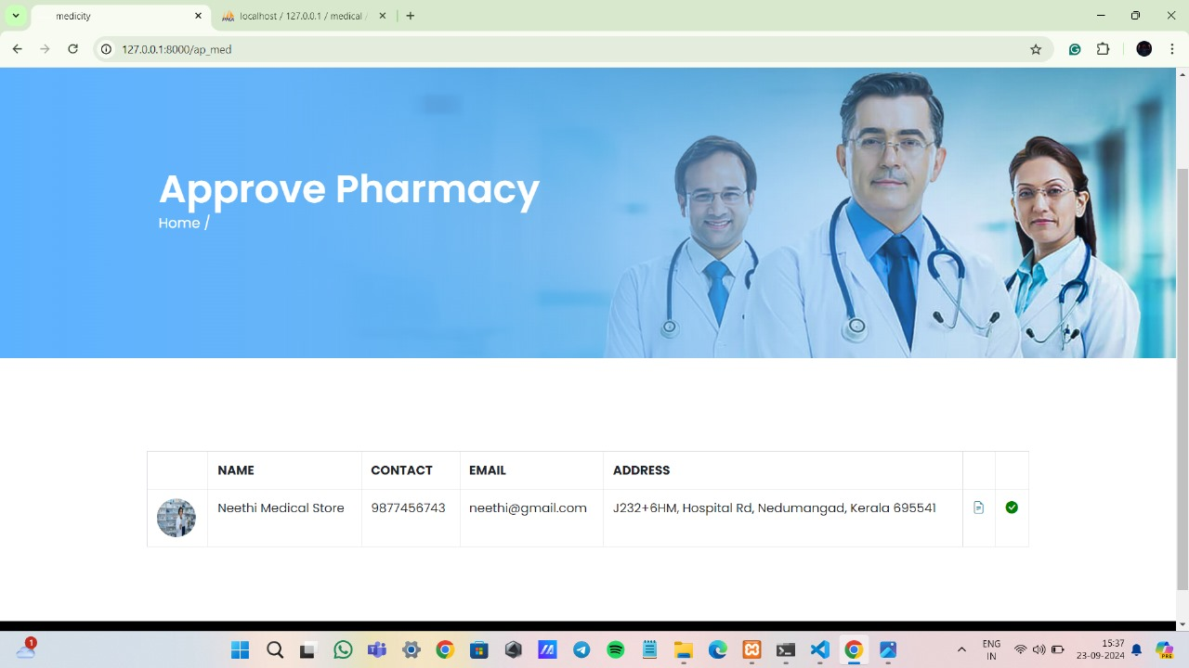

Figure 32 Pharmacy Approval Page

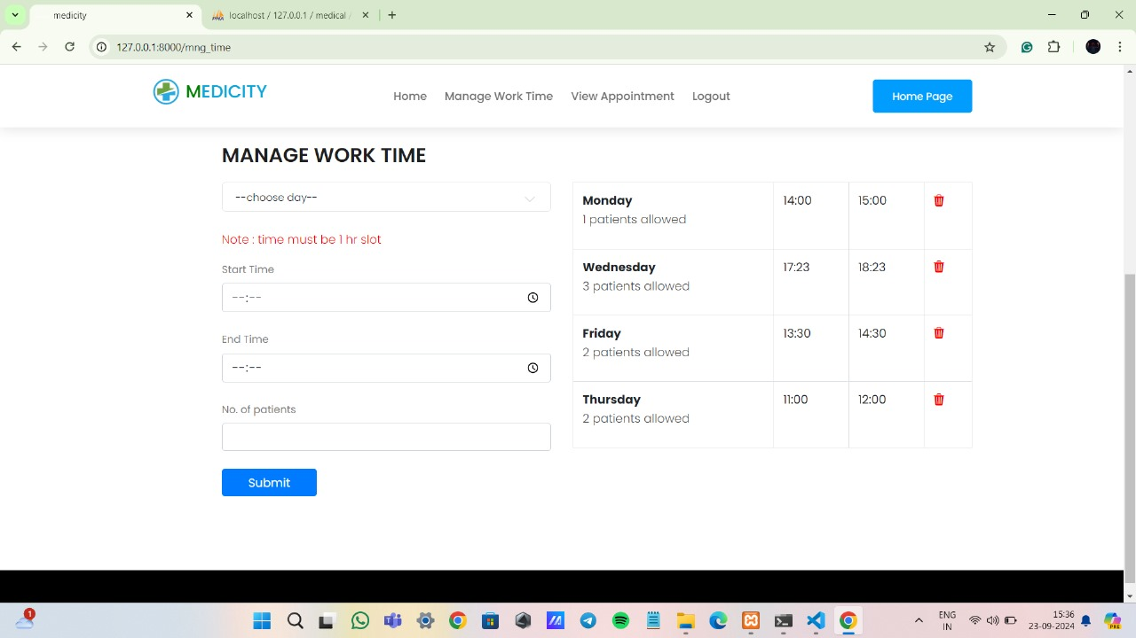

Figure 33 Doctor Time Management Page

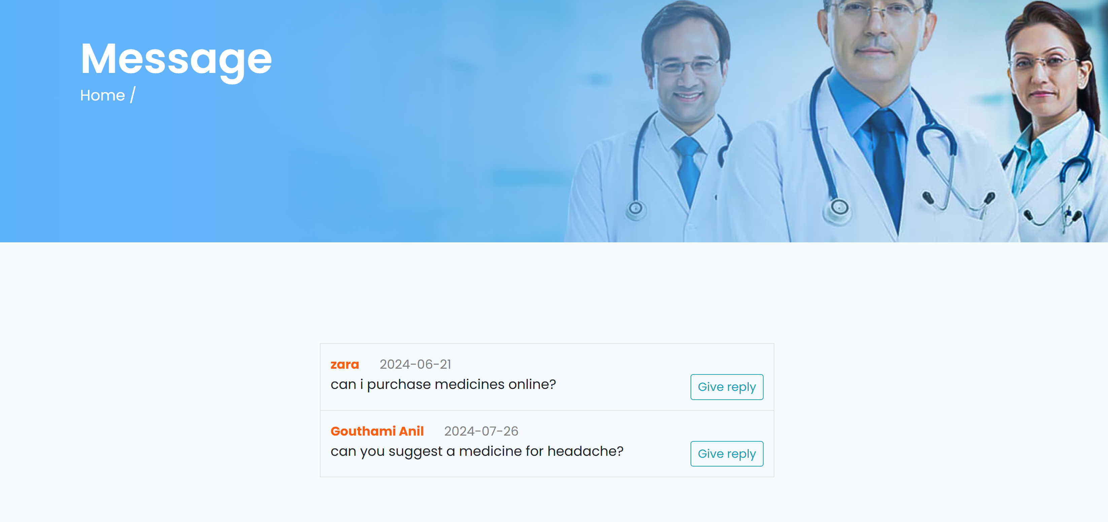

Figure 34 Pharmacy Message View Page

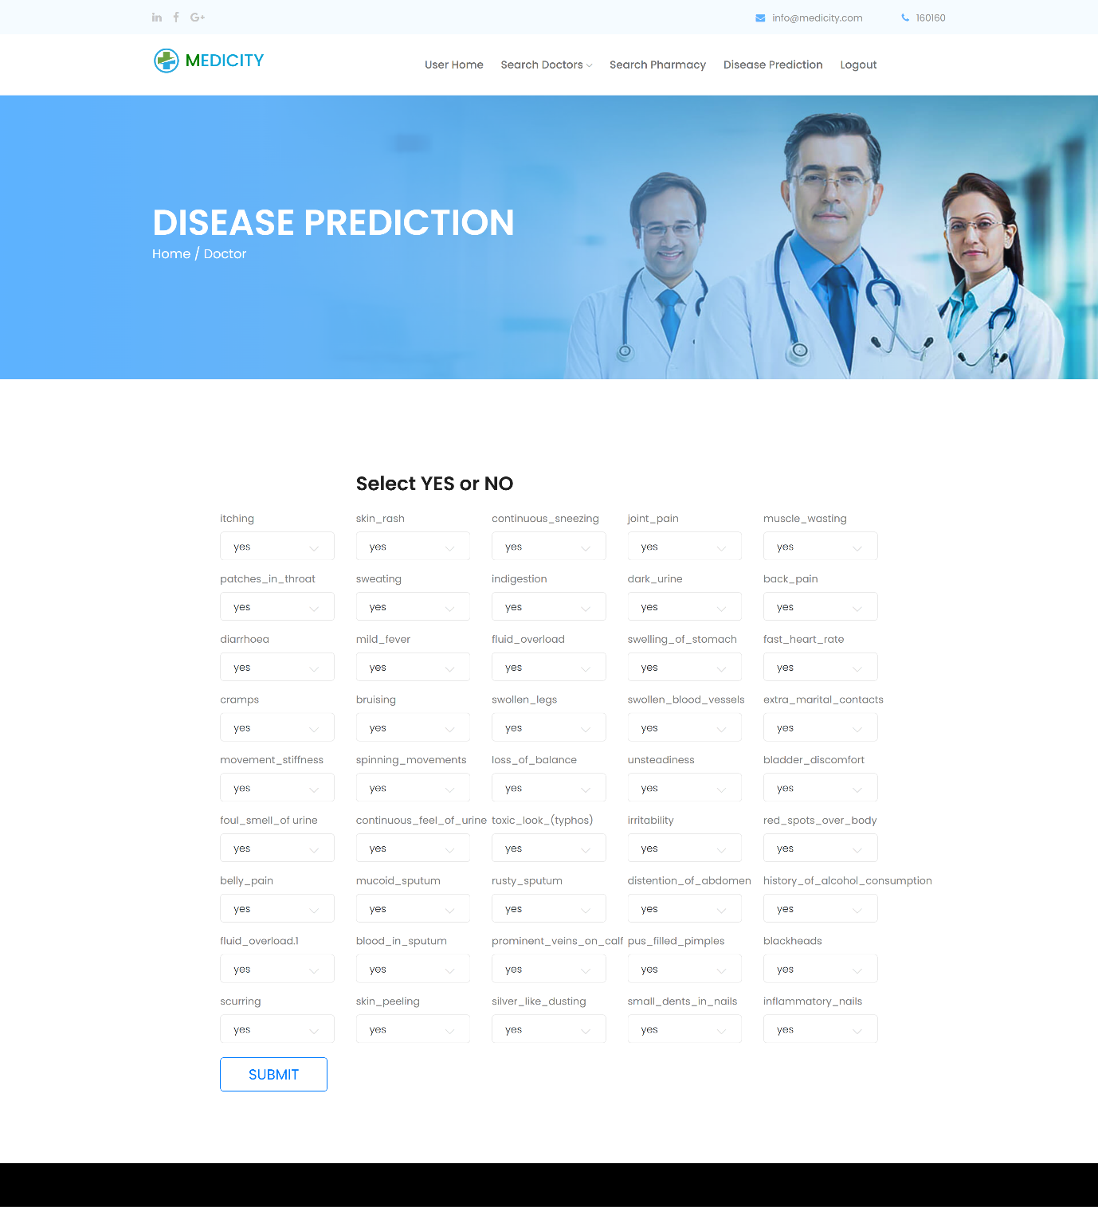

Figure 35 Disease Prediction Page

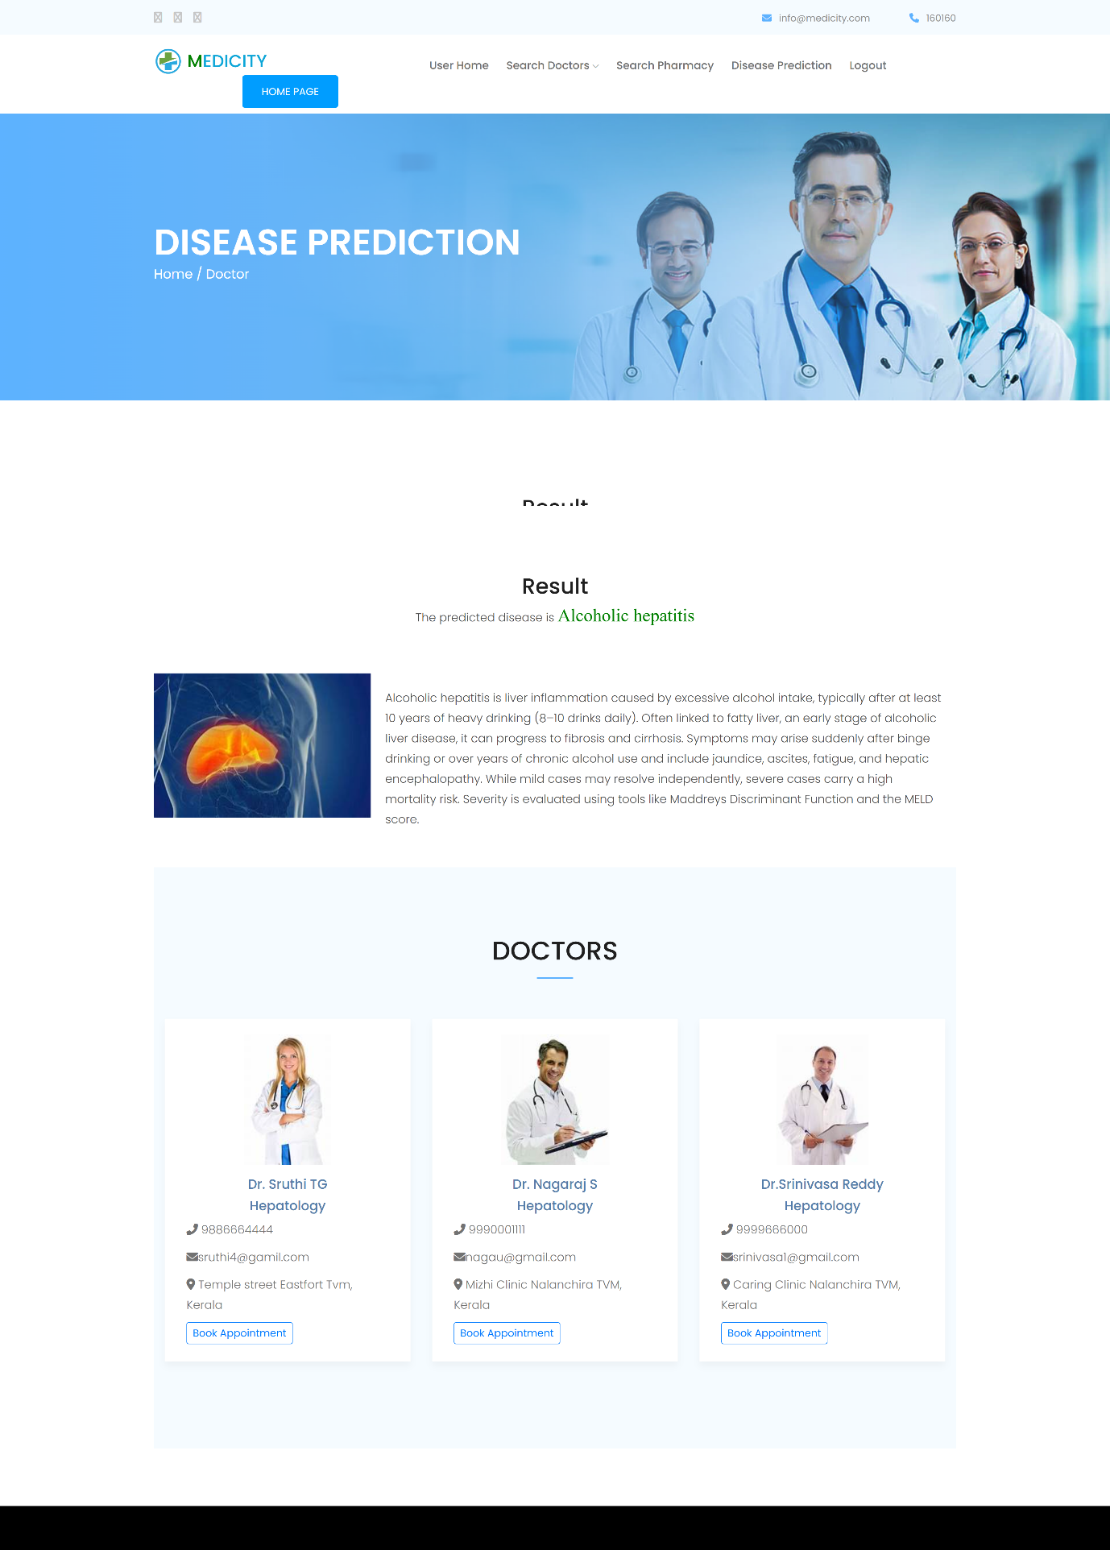

Figure 36 Disease Prediction Result Page

**15. USER MANUAL**

This system is designed to provide seamless healthcare access by connecting users with medical professionals and pharmacies. It includes various modules to ensure efficient healthcare management.

**15.1. User Module**

The User Module helps patients find and connect with doctors and pharmacies easily.

* Doctor Search: Users can search for doctors based on their location or disease category.
* Appointment Booking: Allows users to book consultations with doctors, reducing waiting times.
* Pharmacy Search: Users can find nearby pharmacies.
* Messaging System: Users can directly message pharmacies to inquire about medicine availability or other concerns.

**15.2. Doctor Module**

The Doctor Module enables medical professionals to manage their schedules and appointments efficiently.

* Schedule Management: Doctors can set and update their work schedules.
* Appointment Tracking: Doctors can view and manage upcoming patient appointments.
* Enhanced Coordination: Ensures better communication between doctors and patients for improved healthcare service.

**15.3. Pharmacy Module**

The Pharmacy Module helps pharmacies manage user inquiries and update their availability status.

* Message Handling: Pharmacies can receive and respond to user messages regarding medicine availability.
* Shop Status Updates: Pharmacies can update their operational status (open/closed) to inform users in real time.
* Improved Accessibility: Helps patients locate available pharmacies efficiently.

**15.4. Admin Module**

The Admin Module provides system-wide management and ensures platform integrity.

* Disease Category Management: Admins can add and categorize diseases to help users find specialized doctors.
* Doctor-Patient Matching: Assign doctors to diseases based on their expertise.
* Location Management: Ensures accurate location-based searches for users.
* Verification & Approval: Admins verify and approve doctors and pharmacies before they operate on the platform.

**15.5. Disease Prediction Module**

The Disease Prediction Module helps users identify possible health conditions based on symptoms.

* Symptom Analysis: Uses medical data and algorithms to predict potential diseases.
* Guidance for Medical Attention: Provides users with insights on whether they need to consult a doctor.
* Preventive Healthcare: Enhances early diagnosis, leading to better health outcomes.